**ASSESSING SOCIAL AND BEHAVIORAL FACTORS INFLUENCING CHOLERA**

**PREVENTIVE STRATEGIES IN EIGHT SELECTED DISTRICTS; MALAWI**

**REPORT**

## INTRODUCTION

Globally, an estimated 21,000- 143,000 people die due to cholera, and about 1.3-5.0 million cases of cholera are reported annually [1–3], though the actual numbers are likely much higher due to under-reporting from surveillance challenges, social stigma, and political factors [4]. This is worse in low and middle income countries where infrastructure for water and sanitation is inadequate [3]. Malawi has not been spared, with recurrent cholera outbreaks causing substantial morbidity and mortality since 1998 [5].

Cholera, as a water born disease caused by vibrio cholerae, spreads rapidly and communities with poor access to clean water, good sanitation, and good hygiene practices [6, 7]. In response, the government of Malawi along with some national and local partners have implemented various strategies including water sanitation interventions, oral cholera vaccination campaigns, and public health education [6, 8–10]. Despite the availability of such strategies, effectiveness of these intervention is usually undermined by social and behaviour factors.

So far, several epidemics have been reported since the deadliest outbreak reported in 2002/2003 [11]. According to Ministry of Health (MOH), in 2022/2023 59,376 cases and 1772 deaths were reported [12]. Non availability of safe water, insufficient water treatment, inadequate sanitation, socio-cultural and limited access to cholera vaccine contribute to the recurrent outbreaks [5, 13].

Because cholera affects communities, and is more likely to spread rapidly or become endemic, a multifaceted approach is key to reduce morbidity and mortality and control it [3, 10]. This includes surveillance, addressing socio-cultural factors including access to safe water, improved sanitation and hygiene as well as uptake of oral cholera vaccine [7, 10, 12, 14]. Cholera vaccine provides 75-90% protection in reactive setting [7, 9, 15–17], and the uptake of case area target intervention (CATI) including water safety and sanitation are also effective and have been implemented in various countries [18, 19]. However, understanding factors is key to designing interventions that are culturally appropriate, sustainable, and widely adopted.

While studies have investigated various aspects of Cholera in Malawi such as risk factors, OCV effectiveness, spatial distribution of cholera, and economic impact [2, 3, 21–26, 4, 5, 9–11, 13, 17, 20], gaps remain in understanding how social and behavioural factors influence the uptake of cholera prevention and control measures. Therefore, this study was conducted to assess the social behavioural factors that influence the implementation and uptake of cholera preventive measures in eight selected districts of Malawi: Balaka, Blantyre, Dedza, Likoma, Lilongwe, Mangochi, Nkhatabay and Salima. These districts represent a mix of urban and rural setting, each with unique socio-economic and environmental factors that could influence cholera prevention efforts.

In the advent of recurring threat of cholera in Malawi, the findings provide valuable insights into the social and behavioural factors that influence the uptake of cholera prevention efforts. By examining these elements, the findings could guide the design of targeted public health strategies which can improve the overall response to cholera and contribute to the prevention of future outbreaks in line with global and national health goals. This research, therefore, seeks to contribute to a more sustainable and community driven approach to cholera prevention across the selected districts and beyond.

## METHODOLOGY

**design of study**

This study employed a mixed-methods approach, integrating both quantitative and qualitative methodologies to comprehensively assess the social and behavioral factors influencing cholera prevention efforts. The quantitative component consisted of a cross-sectional survey targeting affected communities, while the qualitative component involved Key Informant Interviews (KII) with stakeholders such as healthcare professionals, community leaders, and policymakers. This methodological triangulation ensured a robust understanding of cholera transmission dynamics and intervention effectiveness.

The study was conducted in eight districts across Malawi: Balaka, Blantyre, Dedza, Likoma, Lilongwe, Mangochi, Nkhatabay, and Salima. These districts were selected based on a calculated mean incidence threshold of 3.27 cases per 1,000 individuals. Blantyre and Lilongwe, classified as urban centers, served as key commercial and administrative hubs, whereas Mangochi, Nkhatabay, and Salima were lakeshore districts with high fishing activity. The diverse geographical and socio-economic characteristics of these study sites provided valuable insights into cholera risk factors across different settings.

The targeted study population represented 40.59% of Malawi’s total population but accounted for 70.11% of the national cholera burden. Additionally, these districts constituted 42.37% of the Priority Area for Multi-Sectoral Intervention (PAMI) Plan for Cholera Control. Data collection was structured to capture both epidemiological trends and contextual determinants, enabling a data-driven approach to inform targeted public health interventions.

**Table 1: Distribution Table of Population, Cumulative Cholera Cases and Deaths and Number of PAMIs the Study Site**

|  |  |  |  |  |
| --- | --- | --- | --- | --- |
| **District** | **Population** | **Cholera cases** | **Cholera death** | **Number of PAMIs** |
| Balaka | 518,003 | 4134 | 82 | 6 |
| Blantyre | 1,406,236 | 8999 | 190 | 7 |
| Dedza | 947,812 | 2124 | 95 | 3 |
| Likoma | 16302 | 204 | 2 | 1 |
| Lilongwe | 3,069,358 | 12716 | 559 | 10 |
| Mangochi | 1388,626 | 8226 | 120 | 9 |
| Nkhata Bay | 314, 810 | 1628 | 49 | 10 |
| Salima | 566, 301 | 2719 | 97 | 11 |

**sample size determination**

The sample size was determined for the quantitative data using a modified Cochrane formula adapted for cross-sectional studies with infinite populations . The formula is given by:

[Insert Formula]

Where:

n = required sample size

Z = Z-value (1.96 for 95% confidence level)

P = prevalence(Assumed at 50%)

d = margin of error (0.05)

DEFF = design effect (2, as recommended for single cluster studies)

The calculated minimum sample size (n) was determined to be 798 households. Consequently, this figure was revised to 878 households to accommodate a projected non-response rate/missing data loss of 10%. To ensure population proportion to size adherence the sample size was re adjusted to 912 distributed as follows:

|  |  |  |  |
| --- | --- | --- | --- |
| **District** | **Population** | **Prop** | **PPS** |
| Balaka | 504,350.00 | 0.063412 | 58 |
| Blantyre | 1,381,066.00 | 0.173643 | 159 |
| Dedza | 928,094.00 | 0.11669 | 107 |
| Likoma | 15,995.00 | 0.002011 | 2 |
| Lilongwe | 2,916,559.00 | 0.366701 | 335 |
| Mangochi | 1,346,740.00 | 0.169327 | 155 |
| Nkhatabay | 309,673.00 | 0.038935 | 36 |
| Salima | 551,022.00 | 0.06928 | 64 |

**Data Management**

Data were collected using an electronic interviewer-guided questionnaire deployed through Kobo Toolbox V2024.1.3 to capture quantitative data efficiently. During the questionnaire design, data validation rules were implemented to ensure completeness by requiring responses before proceeding to the next question. Data management involved standardizing variable names to lowercase, using underscores for multi-word variables (e.g., *vaccine_uptake_score*), and ensuring string values were consistently formatted in lowercase (e.g., *male* instead of *Male*). Duplicate entries were checked by identifying observations with identical records based on key variables such as ID, age, sex, and district. Missing values in critical variables, including age, sex, and social and behavioral factors, were assessed, and appropriate imputation methods were applied based on the identified missing data patterns. These measures ensured data accuracy, consistency, and completeness for subsequent analysis.

**Study Implementation Procedure**

Study implementation commenced with a comprehensive three-day training program for National Level research assitants from **[insert date]** dedicated to the meticulous collection of data, specifically designed for the research assistants who would be engaging in this critical process. The first day of this intensive training program was primarily devoted to the introduction of the study protocol, with the explicit intention of providing a thorough contextual background regarding the overarching aims and objectives of the research study, thereby ensuring that the research assistants were sufficiently equipped with foundational knowledge which would enable them to articulate the questions contained within the questionnaire effectively, ultimately facilitating the collection of coherent and relevant responses from the study participants.

The second day of training was centered around the methodological framework and practical strategies for field implementation, during which the research assistants received specialized instruction on the execution of the systematic sampling procedure, specifically utilizing a Kth value of 15. The initial point for the randomization process was determined to be the residence of the Traditional Authorities, from which the research assistants were instructed to proceed in all possible directions; upon reaching the outer limits of the designated Primary Administrative Management Interface (PAMI), they would then randomly select a new starting point and systematically recruit every Kth participant encountered in that particular direction.

The third day of the training agenda was exclusively focused on the administration of the questionnaire, wherein the research assistants were paired together and tasked with the dual role of interviewer and interviewee, a collaborative exercise that proved instrumental in allowing the interviewee to confront and resolve any potential difficulties encountered in reading the questions aloud or in accurately completing the electronic forms utilized for data collection.

**Implementation Challenges and Workarounds**

The study faced several limitations that impacted data collection and overall implementation. Firstly, there was a misclassification of one Traditional Authority (TA), which was later determined to fall under a different jurisdiction as identified by a senior village head. To address this, the sample size per TA was adjusted accordingly. Additionally, geographical accessibility challenges arose, as two selected TAs were located in remote areas only accessible by boat, leading to logistical difficulties, increased costs, and potential delays. Consequently, these two TAs were not visited, and their sample sizes were redistributed among other TAs within the district. Furthermore, engaging TAs proved challenging due to their busy schedules and the legal requirement for prior approval before visits. As an alternative, the study team engaged senior village chiefs and village heads for entry into the villages, but this may have influenced the depth of insights gained from the higher administrative level. Other challenges included the need to reduce the sample size of household participants to accommodate the available TAs, Health Surveillance Assistants (HSAs), and one District Environmental Health Officer (DEHO). Additionally, data from other Research Assistants was not submitted due to errors, while the vast distances between TAs and the scattered nature of households further complicated data collection. Some TAs declined to participate, citing the absence of a letter of support from the District Commissioner. Lastly, research assistants were not adequately trained, leading to data collection gaps as they required constant guidance and sometimes failed to collect necessary data.

**Data Analysis**

The study examined the frequency of demographic variables, social and behavioral factors influencing water treatment practices, the availability and standards of sanitary services and infrastructure for cholera prevention, and the social and cultural determinants of vaccine uptake, with all findings presented in percentages. To assess the social and behavioral factors influencing water treatment practices, a Water Treatment Practice Score (0–1) was created by summing the total outcome values of key indicators such as awareness of health risks, knowledge of cholera prevention, and water treatment practices, then dividing by the total observations. Similarly, a Sanitary and Infrastructure Score (0–1) was developed by aggregating the binary outcome values of essential sanitary facilities. To evaluate vaccine uptake, a Vaccine Uptake Score was generated based on factors such as awareness, trust in the vaccine, access to information, and willingness to receive or recommend the vaccine. Logistic regression was employed to assess the relationship between these dependent variables and demographic as well as social-behavioral predictors. Additionally, factor analysis was conducted to identify underlying dimensions of behavioral influences, while structural equation modeling (SEM) was utilized to explore complex relationships between predictors and outcomes. Descriptive statistics summarized water treatment practices, while chi-square tests examined associations with cholera incidence. Geospatial analysis mapped sanitary infrastructure, and one-way ANOVA compared cholera incidence across regions with differing infrastructure standards. Multilevel modeling assessed individual- and community-level factors affecting cholera incidence, and propensity score matching was applied to evaluate vaccine effectiveness by controlling for confounders. The qualitative component included Key Informant Interviews (KIIs) with 24 participants, including community leaders and health professionals, to explore social and behavioral factors influencing cholera prevention. Thematic analysis of interview transcripts provided in-depth insights into local perceptions of water treatment, vaccine acceptance, and sanitation challenges. These qualitative findings complemented the quantitative results, offering a comprehensive understanding of the factors influencing cholera prevention efforts.

## RESULTS

#### Demographics of Respondents

Table 1 Demographics of Respondents  (n=797)

|  |  |  |  |
| --- | --- | --- | --- |
| **Variable** | **Categories** | **Frequency** | **Percentage** |
| sex | female | 609 | 76.41 |
| male | 188 | 23.59 |
| Age group | 18-30 | 291 | 36.51 |
| 31-50 | 332 | 41.66 |
| >50 | 174 | 21.83 |
| Level education | none | 108 | 13.55 |
| primary | 501 | 62.86 |
| secondary | 170 | 21.33 |
| tertiary | 18 | 2.26 |
| Occupation | farmer | 374 | 46.93 |
| fisherman | 4 | 0.50 |
| fishsellar | 3 | 0.38 |
| housewife | 117 | 14.68 |
| other business | 189 | 23.71 |
| other occupation | 74 | 9.28 |
| professionalworker | 19 | 2.38 |
| retired | 9 | 1.13 |
| student | 8 | 1.00 |
| Marital status | divorced | 61 | 7.65 |
| married | 568 | 71.27 |
| separated | 29 | 3.64 |
| single | 68 | 8.53 |
| widow | 54 | 6.78 |
| widower | 17 | 2.13 |
| Ethnicity | chewa | 393 | 49.31 |
| lomwe | 65 | 8.16 |
| ngonde | 4 | 0.50 |
| ngoni | 101 | 12.67 |
| nyanja | 14 | 1.76 |
| other enthni | 9 | 1.13 |
| sena | 3 | 0.38 |
| tonga | 24 | 3.01 |
| tumbuka | 11 | 1.38 |
| yao | 173 | 21.71 |
| Religion | Christianity | 593 | 74.40 |
| muslim | 180 | 22.58 |
| others regligion | 24 | 3.01 |

#### Social and Behavioral Factors Influencing Water Treatment

2.1.0 Source of Water for Daily Use by District and TA/Area and Township

**2.2. 1 Awareness of the Health risks associated with drinking untreated Water by Sex, age group, and Level of Education**.

The study assessed awareness of Health risks associated with drinking water across Sex, Age Group, and Level of Education. The Findings show that 90.77% of females were aware of the risk associated with drinking untreated water, and only 9.23% were not aware of the risk. Of males, 87.77% were aware of the risk associated with drinking untreated water, compared to 12.23% of males unaware. Among the age group 50 years above, 93.10% were aware of the risk of drinking untreated water compared to 91.57% and 86.51% of the age group 31-50 and 18-30 years, respectively. Across the level of education, 100% of those who attended Tertiary were aware of the risk associated with drinking untreated water, and of those who attended secondary, 96.47%, Primary 88.58% and those without education 85.19%

| **Awareness of the health Risks associated with drinking untreated water** | | |
| --- | --- | --- |
| **Characteristic** | **no**  N = 79 | **yes**  N = 716 |
| sex |  |  |
| female | 56 (9.23%) | 551 (90.77%) |
| male | 23 (12.23%) | 165 (87.77%) |
| Age group |  |  |
| >50 | 12 (6.90%) | 162 (93.10%) |
| 18-30 | 39 (13.49%) | 250 (86.51%) |
| 31-50 | 28 (8.43%) | 304 (91.57%) |
| Level Education |  |  |
| none | 16 (14.81%) | 92 (85.19%) |
| primary | 57 (11.42%) | 442 (88.58%) |
| secondary | 6 (3.53%) | 164 (96.47%) |
| tertiary | 0 (0.00%) | 18 (100.00%) |
|  | | |

2.2.2 Awareness of the Health Risks Associated with Drinking Untreated Water by District and TA/ Residence

| Awareness of the Health Risk associated with Drinking untreated with water | | |
| --- | --- | --- |
| **Characteristic** | **no**  N = 791 | **yes**  N = 7161 |
| **District** |  |  |
| Balaka | 3 (8.82%) | 31 (91.18%) |
| Blantyre | 12 (9.23%) | 118 (90.77%) |
| Dedza | 8 (7.62%) | 97 (92.38%) |
| Lilongwe | 35 (11.67%) | 265 (88.33%) |
| Mangochi | 16 (12.40%) | 113 (87.60%) |
| Nkhata-bay | 3 (8.33%) | 33 (91.67%) |
| Salima | 2 (3.28%) | 59 (96.72%) |
| **Zone** |  |  |
| Central east | 2 (3.28%) | 59 (96.72%) |
| Central west | 43 (10.62%) | 362 (89.38%) |
| North | 3 (8.33%) | 33 (91.67%) |
| South east | 19 (11.66%) | 144 (88.34%) |
| South west | 12 (9.23%) | 118 (90.77%) |
| 1n (%) | | |

2.3. 0 Main sources of drinking water during the dry season by District

| district | borehole 1 | community standpipe | piped into dwelling | piped into yard plot | protected well 1 | unprotected well 1 | other drinking source | river stream | spring 1 | dam | bottled water | tanker truck bower | lake | total |
| --- | --- | --- | --- | --- | --- | --- | --- | --- | --- | --- | --- | --- | --- | --- |
| Balaka | 100.0 | 0.0 | 0.0 | 0.0 | 0.0 | 0.0 | 0.0 | 0.0 | 0.0 | 0 | 0.0 | 0.0 | 0.0 | 34 |
| Blantyre | 74.6 | 4.6 | 10.8 | 6.9 | 0.8 | 2.3 | 0.0 | 0.0 | 0.0 | 0 | 0.0 | 0.0 | 0.0 | 130 |
| Dedza | 81.0 | 1.9 | 0.9 | 1.9 | 4.8 | 6.7 | 0.9 | 0.9 | 0.9 | 0 | 0.0 | 0.0 | 0.0 | 105 |
| Lilongwe | 82.3 | 0.7 | 0.7 | 2.7 | 7.3 | 2.3 | 0.0 | 2.3 | 0.0 | 0 | 0.0 | 0.0 | 0.0 | 300 |
| Mangochi | 86.8 | 2.3 | 1.6 | 5.4 | 0.0 | 0.0 | 0.0 | 0.0 | 0.0 | 0 | 1.6 | 2.3 | 0.0 | 129 |
| Nkhata-bay | 38.9 | 5.6 | 8.3 | 30.6 | 2.8 | 0.0 | 2.8 | 5.6 | 0.0 | 0 | 0.0 | 0.0 | 5.6 | 36 |
| Salima | 88.5 | 1.6 | 0.0 | 8.2 | 1.6 | 0.0 | 0.0 | 0.0 | 0.0 | 0 | 0.0 | 0.0 | 0.0 | 61 |

By Zone

| zone | borehole 1 | community standpipe | piped into yard plot | protected well | dam | other drinking source | piped into dwelling | river stream | spring 1 | unprotected well 1 | lake | bottled water | tanker truck bower | total |
| --- | --- | --- | --- | --- | --- | --- | --- | --- | --- | --- | --- | --- | --- | --- |
| Central east | 88.5 | 1.6 | 8.2 | 1.6 | 0 | 0.0 | 0.0 | 0.0 | 0.0 | 0.0 | 0.0 | 0.0 | 0.0 | 61 |
| Central west | 82.0 | 1.0 | 2.5 | 6.7 | 0 | 0.2 | 0.7 | 2.0 | 0.2 | 3.5 | 0.0 | 0.0 | 0.0 | 405 |
| north | 38.9 | 5.6 | 30.6 | 2.8 | 0 | 2.8 | 8.3 | 5.6 | 0.0 | 0.0 | 5.6 | 0.0 | 0.0 | 36 |
| South east | 89.6 | 1.8 | 4.3 | 0.0 | 0 | 0.0 | 1.2 | 0.0 | 0.0 | 0.0 | 0.0 | 1.2 | 1.8 | 163 |
| South west | 74.6 | 4.6 | 6.9 | 0.8 | 0 | 0.0 | 10.8 | 0.0 | 0.0 | 2.3 | 0.0 | 0.0 | 0.0 | 130 |

2.4. 0 Main sources of drinking water during the wet season by District and Zone

| district | borehole | community standpipe | dam | lake | piped into dwelling | piped into yard plot | protected well | rainwater | unprotected well | other drinking source | spring 1 | river stream | tanker truck bower | bottled water | total |
| --- | --- | --- | --- | --- | --- | --- | --- | --- | --- | --- | --- | --- | --- | --- | --- |
| Balaka | 100.0 | 0.0 | 0 | 0.0 | 0.0 | 0.0 | 0.0 | 0 | 0.0 | 0.0 | 0.0 | 0.0 | 0.0 | 0.0 | 34 |
| Blantyre | 72.3 | 3.8 | 0 | 0.8 | 10.0 | 4.6 | 0.8 | 5 | 3.1 | 0.0 | 0.0 | 0.0 | 0.0 | 0.0 | 130 |
| Dedza | 80.0 | 2.9 | 0 | 0.0 | 0.9 | 0.9 | 1.9 | 7 | 4.8 | 0.9 | 0.9 | 0.0 | 0.0 | 0.0 | 105 |
| Lilongwe | 78.3 | 0.7 | 0 | 0.0 | 0.3 | 2.3 | 8.7 | 7 | 3.3 | 0.0 | 0.0 | 1.7 | 0.3 | 0.0 | 300 |
| Mangochi | 84.5 | 3.1 | 0 | 0.0 | 1.6 | 4.6 | 0.0 | 1 | 0.0 | 0.0 | 0.8 | 0.8 | 2.3 | 1.6 | 129 |
| Nkhata-bay | 41.7 | 5.6 | 0 | 0.0 | 8.3 | 30.6 | 0.0 | 3 | 0.0 | 0.0 | 0.0 | 5.6 | 0.0 | 0.0 | 36 |
| Salima | 85.2 | 0.0 | 0 | 0.0 | 0.0 | 11.5 | 1.6 | 1 | 0.0 | 0.0 | 0.0 | 0.0 | 0.0 | 0.0 | 61 |

By Zone

| zone | borehole 1 | piped into yard plot | protected well 1 | rainwater | community standpipe | dam | other drinking source | piped into dwelling | river stream | spring 1 | tanker truck bower | unprotected well 1 | bottled water | lake | total |
| --- | --- | --- | --- | --- | --- | --- | --- | --- | --- | --- | --- | --- | --- | --- | --- |
| Central east | 85.2 | 11.5 | 1.6 | 1 | 0.0 | 0 | 0.0 | 0.0 | 0.0 | 0.0 | 0.0 | 0.0 | 0.0 | 0.0 | 61 |
| Central west | 78.8 | 2.0 | 6.9 | 14 | 1.2 | 0 | 0.2 | 0.5 | 1.2 | 0.2 | 0.2 | 3.7 | 0.0 | 0.0 | 405 |
| north | 41.7 | 30.6 | 0.0 | 3 | 5.6 | 0 | 0.0 | 8.3 | 5.6 | 0.0 | 0.0 | 0.0 | 0.0 | 0.0 | 36 |
| South east | 87.7 | 3.7 | 0.0 | 1 | 2.4 | 0 | 0.0 | 1.2 | 0.6 | 0.6 | 1.8 | 0.0 | 1.2 | 0.0 | 163 |
| South west | 72.3 | 4.6 | 0.8 | 5 | 3.8 | 0 | 0.0 | 10.0 | 0.0 | 0.0 | 0.0 | 3.1 | 0.0 | 0.8 | 130 |

2.5.1 Water Treatment at Household by Sex, Age Group Level of Education, Religion

| **Water Treatment at Household level** | | |
| --- | --- | --- |
| **Characteristic** | **no**  N = 299 | **yes**  N = 496 |
| sex |  |  |
| female | 209 (34.43%) | 398 (65.57%) |
| male | 90 (47.87%) | 98 (52.13%) |
| Age group |  |  |
| >50 | 59 (33.91%) | 115 (66.09%) |
| 18-30 | 118 (40.83%) | 171 (59.17%) |
| 31-50 | 122 (36.75%) | 210 (63.25%) |
| Level Education |  |  |
| none | 52 (48.15%) | 56 (51.85%) |
| primary | 187 (37.47%) | 312 (62.53%) |
| secondary | 53 (31.18%) | 117 (68.82%) |
| tertiary | 7 (38.89%) | 11 (61.11%) |
| religion |  |  |
| Christianity | 231 (39.02%) | 361 (60.98%) |
| Muslim | 54 (30.17%) | 125 (69.83%) |
| Others religion | 14 (58.33%) | 10 (41.67%) |

2.5.2 Water Treatment at Household by District and Zone

| **Water Treatment at Household level** | | |
| --- | --- | --- |
| **Characteristic** | **no**  N = 2991 | **yes**  N = 4961 |
| District |  |  |
| Balaka | 11 (32.35%) | 23 (67.65%) |
| Blantyre | 37 (28.46%) | 93 (71.54%) |
| Dedza | 58 (55.24%) | 47 (44.76%) |
| Lilongwe | 133 (44.33%) | 167 (55.67%) |
| Mangochi | 29 (22.48%) | 100 (77.52%) |
| Nkhata-bay | 15 (41.67%) | 21 (58.33%) |
| Salima | 16 (26.23%) | 45 (73.77%) |
| Zone |  |  |
| Central east | 16 (26.23%) | 45 (73.77%) |
| Central west | 191 (47.16%) | 214 (52.84%) |
| North | 15 (41.67%) | 21 (58.33%) |
| South east | 40 (24.54%) | 123 (75.46%) |
| South west | 37 (28.46%) | 93 (71.54%) |

2.5.3 if yes, Methods of water treatment by Sex, Age Education and Religion

| Variable |  | boiling | ceramic filter | filter with cloth | others methods | solar disinfection | stand settle | use chlorine | use water from tap | total |
| --- | --- | --- | --- | --- | --- | --- | --- | --- | --- | --- |
| Sex | female | 16.2 | 0.4 | 4.9 | 8.3 | 0.2 | 1.7 | 65.8 | 2.4 | 468 |
|  | male | 26.1 | 0.0 | 5.0 | 3.4 | 0.8 | 5.9 | 57.1 | 1.7 | 119 |
| Age Group | 18-30 | 17.2 | 1.0 | 6.2 | 10.1 | 0.0 | 3.4 | 59.3 | 2.9 | 209 |
|  | 31-50 | 19.0 | 0.0 | 4.2 | 5.1 | 0.4 | 1.7 | 68.3 | 1.3 | 237 |
|  | >50 | 18.4 | 0.0 | 4.3 | 7.1 | 0.7 | 2.8 | 63.8 | 2.8 | 141 |
| Education | none | 9.8 | 0.0 | 6.6 | 0.0 | 0.0 | 0.0 | 80.3 | 3.3 | 61 |
|  | primary | 18.9 | 0.0 | 4.5 | 7.5 | 0.3 | 2.7 | 64.5 | 1.6 | 375 |
|  | secondary | 19.7 | 1.5 | 5.8 | 9.5 | 0.7 | 2.9 | 56.2 | 3.6 | 137 |
|  | tertiary | 21.4 | 0.0 | 0.0 | 14.3 | 0.0 | 7.1 | 57.1 | 0.0 | 14 |
| Religion | Christianity | 21.1 | 0.2 | 4.8 | 8.5 | 0.5 | 2.8 | 59.6 | 2.5 | 436 |

2.5.4 if yes, Methods of water treatment by District

| District | boiling | ceramic filter | filter with cloth | others methods | solar disinfection | stand settle | use chlorine | use water from tap | total |
| --- | --- | --- | --- | --- | --- | --- | --- | --- | --- |
| Balaka | 18.5 | 0.0 | 0.0 | 3.7 | 0.0 | 0.0 | 77.8 | 0.0 | 27 |
| Blantyre | 14.0 | 1.9 | 2.8 | 8.4 | 0.0 | 4.7 | 66.4 | 1.9 | 107 |
| Dedza | 20.0 | 0.0 | 7.3 | 12.7 | 0.0 | 5.4 | 54.5 | 0.0 | 55 |
| Lilongwe | 20.6 | 0.0 | 6.4 | 9.3 | 1.0 | 2.9 | 56.9 | 2.9 | 204 |
| Mangochi | 9.0 | 0.0 | 5.4 | 0.9 | 0.0 | 0.9 | 82.9 | 0.9 | 111 |
| Nkhata-bay | 32.1 | 0.0 | 3.6 | 10.7 | 0.0 | 0.0 | 39.3 | 14.3 | 28 |
| Salima | 27.3 | 0.0 | 3.6 | 5.4 | 0.0 | 0.0 | 63.6 | 0.0 | 55 |

2.5.4 Properly chlorination process by district.

| **The chlorination process is explained correctly** | | |
| --- | --- | --- |
| **Characteristic** | **no**  N = 113 | **yes**  N = 263 |
| sex |  |  |
| female | 95 (30.84%) | 213 (69.16%) |
| male | 18 (26.47%) | 50 (73.53%) |
| Age group |  |  |
| >50 | 31 (34.44%) | 59 (65.56%) |
| 18-30 | 32 (25.81%) | 92 (74.19%) |
| 31-50 | 50 (30.86%) | 112 (69.14%) |
| Level education |  |  |
| none | 24 (48.98%) | 25 (51.02%) |
| primary | 69 (28.51%) | 173 (71.49%) |
| secondary | 18 (23.38%) | 59 (76.62%) |
| tertiary | 2 (25.00%) | 6 (75.00%) |
| religion |  |  |
| Christianity | 77 (29.62%) | 183 (70.38%) |
| Muslim | 35 (31.53%) | 76 (68.47%) |
| Others religion | 1 (20.00%) | 4 (80.00%) |

2.5.4 Properly chlorination process by district.

| **The chlorination process explained correctly.** | | |
| --- | --- | --- |
| **Characteristic** | **no**  N = 113 | **yes**  N = 263 |
| district |  |  |
| Balaka | 4 (19.05%) | 17 (80.95%) |
| Blantyre | 24 (33.80%) | 47 (66.20%) |
| Dedza | 6 (20.00%) | 24 (80.00%) |
| Lilongwe | 43 (37.07%) | 73 (62.93%) |
| Mangochi | 23 (25.00%) | 69 (75.00%) |
| Nkhatabay | 1 (9.09%) | 10 (90.91%) |
| Salima | 12 (34.29%) | 23 (65.71%) |

2.5. 5 Frequency of water treatment by Sex, Level of Education, Religion

2. 5.6 Access to water treatment by district

2. 6.0 Knowledge of cholera calendar year. By Sex, Level of Education, Religion

2. 7. 0 Knowledge of the potential Cause of Cholera.

2.8. 0 Knowledge of the Prevention Measures of cholera by Sex, Level of Education and Religious Belief.

2.8. 0 Knowledge of the Prevention Measures of cholera by District

2. 9.0 Current local measures or campaigns in place to prevent cholera outbreaks by Districts

2. 10.0 Tradition beliefs or Customs related to water treatment in the Community.

**Social and cultural behavior determinants of vaccine uptake**

**3.1. 0 Aware of Cholera Vaccine by Age- Group, Sex Level of Education,**

**3.1. 1 Aware of Cholera Vaccine by District and Zone**

**3.2.0 Believe Cholera Vaccine Prevent Cholera by Sex, Level of Education**

**3.2.1 Believe Cholera Vaccine Prevent District and Zone**

**3.3. 0 Information about Cholera Vaccine by Sex, Age Group, Education, Religion**

**3.3. 1 Information about Cholera Vaccine by District and Zone**

**3. 4. 0 Safe of Cholera Vaccine by Sex Age Group Education and Religion**

**3. 4. 1 Safe of Cholera Vaccine by District and Zone**

**3. 5. 0 Community Influence decision about vaccination by District and Zone**

**3. 6. 0 Difficult in access cholera vaccination by Sex, Education and Religion**

**3. 6. 1 Difficult in access cholera vaccination by District**

**3. 7. 0 OCV status by Sex, Age Group, Education and Religious**

**3. 7. 0 OCV status by District and Zone**

**3. 8. 0 Family Members vaccinated by District and Zone**

**3. 9. 0 Willingness to get vaccinated in the Future OCV by Sex, Age Group and Education**

**3. 9. 1 Willingness to get vaccinated in the Future OCV by District and Zone**

**3. 10. 0 Recommend a Family member to get vaccinated by District and Zone**

**3.**

,

3. 13. 0 Prefer ways to Receive Information about Vaccine by Sex, Age Group and Education and Religious

3. 13. 1 Prefer ways to Receive Information about Vaccine by District and Zone

**Table 3 : Availability of  Household Facilities**

|  |  |  |
| --- | --- | --- |
| **Item** | **Freq.** | **Percent** |
| **Household Handwashing Facility** |  |  |
| Available | 240 | 30.23 |
| Not available | 554 | 69.77 |
| **Observe availability of water at the place for handwashing.** |  |  |
| Available | 238 | 29.97 |
| Not available | 556 | 70.03 |
| **Availability of Soap or Detergent for Hand Washing** |  |  |
| Available | 171 | 21.54 |
| Not available | 623 | 78.46 |
| Total | 794 | 100 |
| **Drainage Around Household** |  |  |
| Good drainage | 527 | 66.37 |
| Stagnant Water Present | 267 | 33.63 |
| **Wastewater from Toilet/Bathroom/Kitchen** |  |  |
| Not properly channeled | 344 | 43.32 |
| Properly channeled | 450 | 56.68 |

|  |  |
| --- | --- |
| Salima | Blantyre |
| Lilongwe | Dedza |
| Mangochi | NKhata Bay |
| Balaka | |

Table 4 presents findings ta on toilet facilities, it reveals that while 93.70% of households had access to a toilet facility, a commendable majority, there are still 6.30% without access, highlighting a critical gap in basic sanitation. Among the toilets available, 67.63% were clean, yet 32.37% were not maintained to hygienic standards, which poses a health risk, particularly in preventing diseases like cholera. Additionally, only 45.34% of toilet facilities were covered or contained, with 54.66% left uncovered, potentially allowing for contamination of the environment and spread of pathogens.

**Table 4: Availability of Toilet Facilities**

|  |  |  |
| --- | --- | --- |
| **Item** | **Freq.** | **Percent** |
| **Toilet Facility** |  |  |
| Available | 744 | 93.70 |
| Not available | 50 | 6.30 |
| **Toilet cleanliness** |  |  |
| Clean | 537 | 67.63 |
| Not Clean | 257 | 32.37 |
| **Is the toilet facility covered/contained?** |  |  |
| no | 434 | 54.66 |
| yes | 360 | 45.34 |

Table 5 illustrates the findings on household refuse pit availability indicate that 59.70% of households had a designated refuse pit for solid waste disposal, while 40.30% lacked one, potentially leading to improper waste management and environmental contamination. Among households, 34.76% had no refuse pit at all, while 22.29% had pits that were overflowing, indicating inadequate waste management capacity. Only 42.95% of refuse pits were properly maintained, highlighting the need for improved waste disposal practices.

**Table 5: Availability of Household Refuse Pits**

|  |  |  |
| --- | --- | --- |
| Item | Freq. | Percent |
| **Refuse Pit (Solid Waste Disposal)** |  |  |
| Available | 474 | 59.70 |
| Not available | 320 | 40.30 |
| **Refuse Pit Condition** |  |  |
| No Pit | 276 | 34.76 |
| Overflowing | 177 | 22.29 |
| Properly maintained | 341 | 42.95 |

Table 6 presents the assessment of household bath shelters or bathrooms reveals that 93.95% of households had an available bathroom, while 6.05% lacked one, which could pose hygiene challenges. Regarding cleanliness, 67.38% of bathrooms were categorized as clean, whereas 32.62% were not, indicating a need for improved sanitation and maintenance practices. The presence of unclean bath shelters may contribute to poor hygiene and increased risk of disease transmission

**Table 6 : Availability and Condition of Bath Shelter / Bathroom**

|  |  |  |
| --- | --- | --- |
| **Item** | **Freq.** | **Percent** |
| **Bath Shelter / Bathroom** |  |  |
| Available | 746 | 93.95 |
| Not available | 48 | 6.05 |
| **Bathroom Condition** |  |  |
| Clean | 535 | 67.38 |
| Not Clean | 259 | 32.62 |

Table 7 represent findings on kitchen facilities indicate that 69.77% of households had a designated kitchen area, while 30.23% did not, suggesting that a significant proportion of households may be preparing food in less ideal conditions. In terms of cleanliness, 60.45% of kitchens were reported as clean, whereas 39.55% were not, raising concerns about potential food contamination risks. Additionally, 52.90% of households had safe food storage, while 47.10% lacked it, which could contribute to foodborne illnesses.

**Table 7: Availability and Cleanliness of Kitchen Facility**

|  |  |  |
| --- | --- | --- |
| Item | Freq. | Percent |
| **Designated Kitchen Area** |  |  |
| Available | 554 | 69.77 |
| Not available | 240 | 30.23 |
| **Cleanliness of Kitchen area** |  |  |
| Clean | 480 | 60.45 |
| Not Clean | 314 | 39.55 |
| **Safe Storage of Food** |  |  |
| Available | 420 | 52.90 |
| Not available | 374 | 47.10 |

1.3. Social and behavioral factors that influence current water treatment practices

Figure 2 below shows the main source of drinking water during the dry and wet seasons. The study reveals that most participants indicated that a borehole is the main source of drinking water in both the dry season and the wet season, representing 80.8% and 78.3%, respectively.

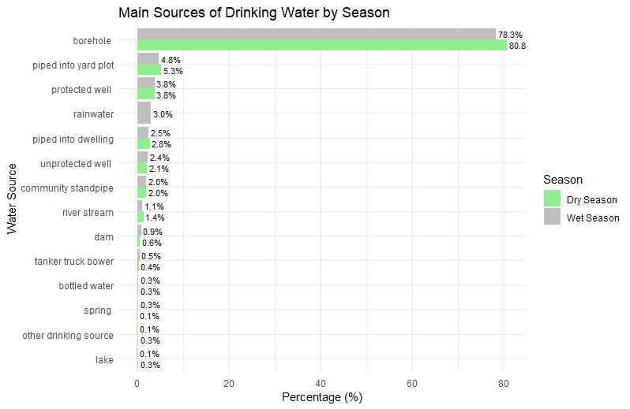

*Figure 2: The graph of Main source of drinking water during the dry and wet season (n=797, %)*

Figure 3 below represents awareness of the health risks associated with untreated drinking water. Out of 797 participants, 718 (90.1%) indicated that there are health risks associated with drinking untreated water.

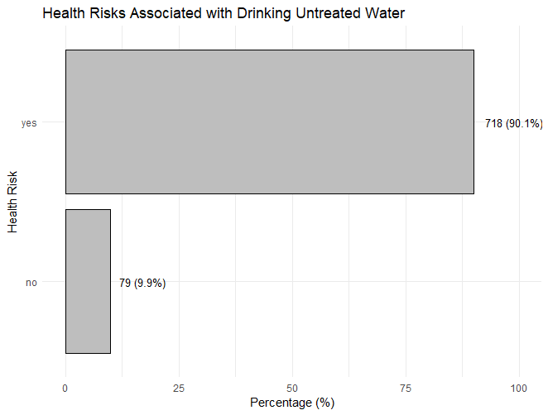

*Figure 3:Awareness of health risk of untreated drinking water*

Figure 4 below illustrates the water treatment methods used by participants. The majority use chlorine (75.9%), followed by boiling (21.5%)

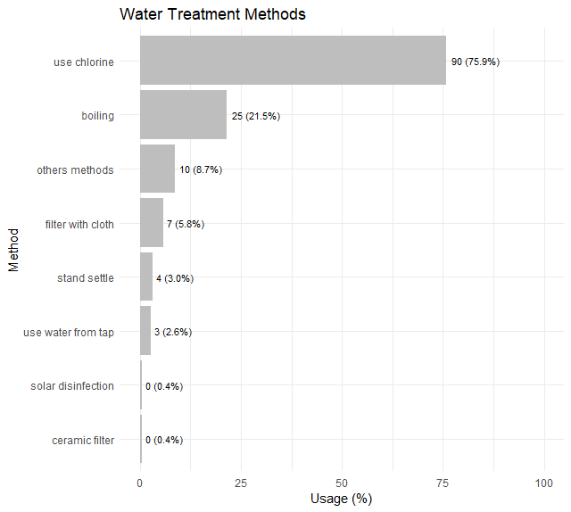

*Figure 4:Water treatment methods(n,%)*

Table 8 below shows water supply. The majority of participants (62.36%) treat their drinking water, while 37.64% do not. Additionally, 28.86% report difficulties in accessing water treatment products, whereas 33.50% do not face such challenges and majority of participants (75.30%)  aware of traditional beliefs or customs related to water treatment

Table 8:  Water supply and traditional beliefs

|  |  |  |  |
| --- | --- | --- | --- |
| **Variable** | **Categories** | **Frequency** | **Percentage** |
| Treat drinking water | no | 300 | 37.64 |
| yes | 497 | 62.36 |
| Difficulties accessing water treatment products | no | 267 | 33.50 |
| yes | 230 | 28.86 |
| Traditional beliefs or customs related to water treatment awareness | Yes | 600 | 75.30 |
| No | 197 | 24.70 |

Figure 5 below shows knowledge on cholera season. The study revealed that the majority of participants (95.2%) believe cholera occurs during the rainy season.

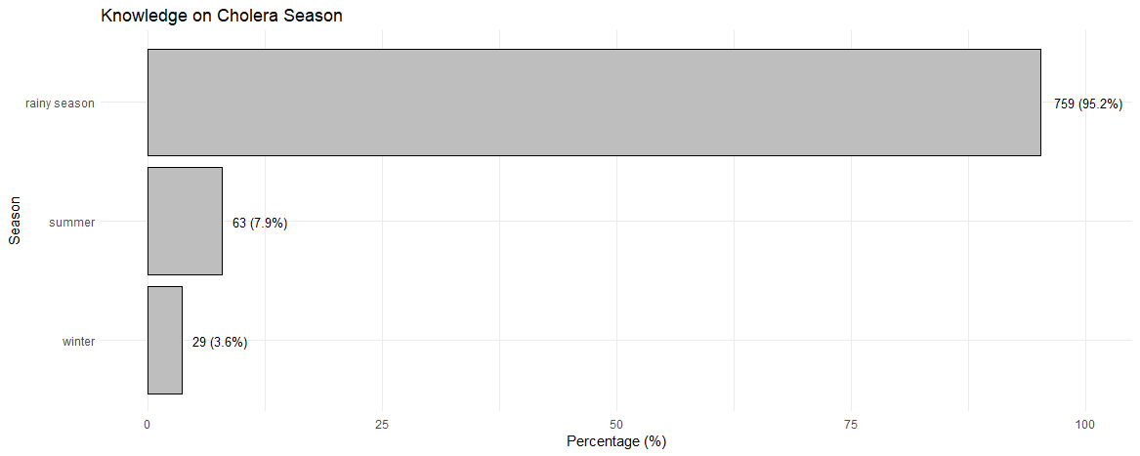

*Figure 5: Knowledge on cholera season*

Figure 6 below illustrates the perceived causes of cholera among participants. The majority identified lack of safe drinking water (56.5%) and an unhygienic living environment (52.8%) as primary contributors,followed by unhygienic disposal of excreta and refuse (47.2%) and eating rotten food (44.4%).

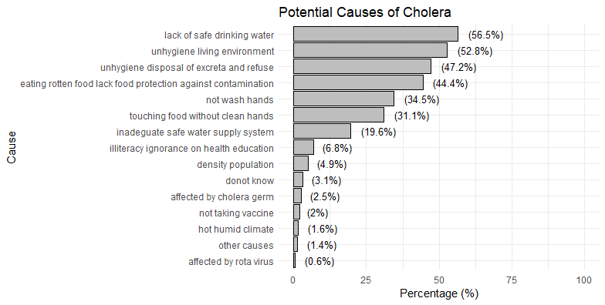

*figure 6: Potential causes of cholera*

The study revealed that the majority of participants use safe water as a cholera prevention measure (see Figure 7), and most participants always wash their hands after using the toilet (see Figure 8).

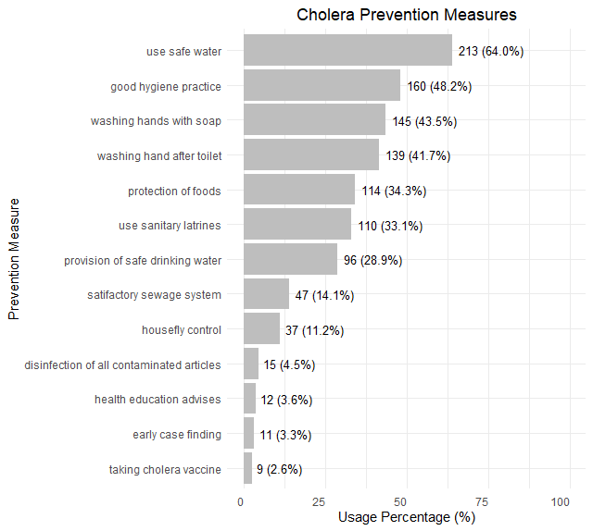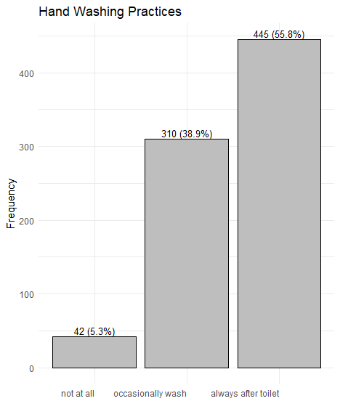

*Figure 7:Cholera Prevention Measures (n=720,%)                                 Figure 8: Hand Washing Practices (n=797,%)*

#### social and cultural behavior determinants of vaccine uptake.

Table 9 below shows awareness and perceptions regarding the cholera vaccine. Most participants have not heard of the cholera vaccine (72.90%). Most participants believe the vaccine can prevent cholera (72.5%). Regarding safety perceptions, the majority consider the vaccine very safe (75.91%). Community beliefs influence the decisions of most participants to get vaccinated (71.65%). Access to vaccination is reported to be easily accessible by the majority (64.5%).

Table 9: Awareness and perceptions regarding the cholera vaccine

|  |  |  |  |
| --- | --- | --- | --- |
| Variable | Categories | Frequency | Percentage |
| Ever heard about Cholera Vaccine | Yes | 216 | 27.10 |
| No | 581 | 72.90 |
| Believe if Cholera Vaccines prevent Cholera Diseases | Yes | 578 | 72.5 |
| No | 66 | 8.28 |
| Not Sure | 91 | 11.4 |
| Don't Know | 62 | 7.78 |
| Cholera vaccine do you think will be safe for you | I don't know | 116 | 14.55 |
| a little safe | 28 | 3.51 |
| moderate safe | 22 | 2.76 |
| not safe at all | 26 | 3.26 |
| very safe | 605 | 75.91 |
| Any beliefs in your community influence your decision to get cholera vaccine | Yes | 561 | 71.65 |
| No | 222 | 28.35 |
| How easy or difficulties to access cholera vaccination | Easily accessible | 514 | 64.5 |
| Not easily accessible | 160 | 20.1 |
| Not accessible | 45 | 5.65 |
| I don't know | 78 | 9.79 |

Figure 9 below illustrates common beliefs influencing decisions to get vaccinated. Most participants indicated that religious (48.2%) and cultural/traditional (47.7%) beliefs affect their vaccination decisions.

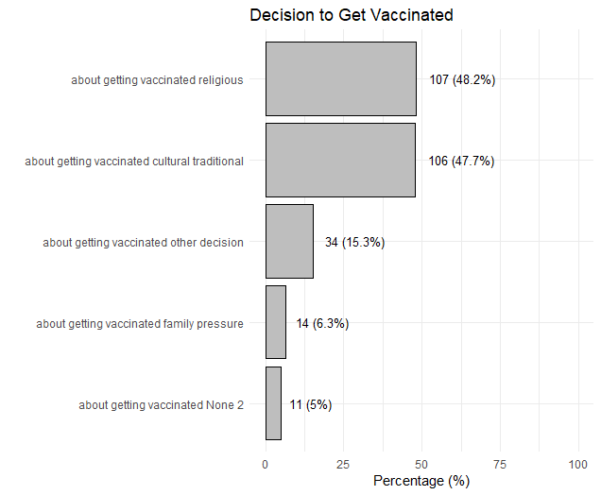

*Figure 9 :Common beliefs that influence decision to get vaccinated*

A majority of participants (58.59%) have not received the cholera vaccine. Among those who received the vaccine, 56.06% received one dose, 38.48% received two doses, and 5.45% were unsure of the number of doses received. Regarding vaccination availability, the majority of participants stated that they would get vaccinated as soon as possible if the vaccine were available near their facility (88.08%). When asked if they would recommend the cholera vaccine to their family, 92.35% would, while 3.39% would not, and 3.14% were unsure. As for their family members’ vaccination status, 59.47% reported that their family members had not received the vaccine, while 40.53% had. In terms of whether family members and friends would get vaccinated, 86.45% of participants believed they would, while 3.39% believed they would not, and 8.78% were unsure. Regarding whether most people at their workplace, school, or community would get vaccinated, 82.06% believed they would, 12.67% were unsure, and 3.01% believed they would not. (See Table 10)

Table 10: Vaccine Uptake Behavior

|  |  |  |  |
| --- | --- | --- | --- |
| Variable | Categories | Frequency | Percentage |
| Cholera Vaccine Status | No | 467 | 58.59 |
| Yes | 330 | 41.41 |
| Number Oral Cholera  Doses Received | Don't know dose | 18 | 5.45 |
| One dose | 185 | 56.06 |
| Two dose | 127 | 38.48 |
| If cholera Vaccine available near Facility will you get vaccinated | No | 34 | 4.27 |
| Not sure to get | 31 | 3.89 |
| Yes but wait to get it  later | 30 | 3.76 |
| Yes would get it as soon as possible | 702 | 88.08 |
| Would you recommend your  family to get cholera vaccine | Do not know | 9 | 1.13 |
| No | 27 | 3.39 |
| Not sure | 25 | 3.14 |
| Yes | 736 | 92.35 |
| Family members cholera vaccine status | No | 474 | 59.47 |
| Yes | 323 | 40.53 |
| Will family member and friend get Cholera vaccine | do not know | 11 | 1.38 |
| no | 27 | 3.39 |
| not sure | 70 | 8.78 |
| yes | 689 | 86.45 |
| Will  most people at your work,school or community get vaccinated | do not know | 18 | 2.26 |
| no | 24 | 3.01 |
| not sure | 101 | 12.67 |
| yes | 654 | 82.06 |

The study revealed that the majority of participants were unaware of any campaigns in place to prevent cholera outbreaks (see Figure 10). Additionally, many indicated that healthcare providers are the main source of information on the oral cholera vaccine (see Figure 11).

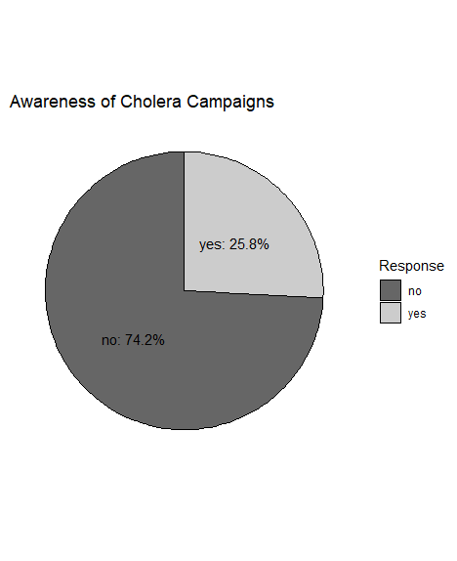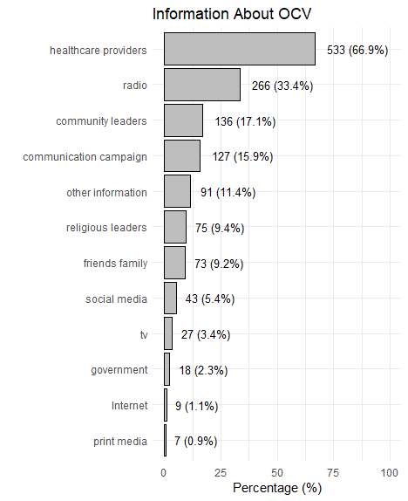

*Figure 10: Awareness of Cholera Campaigns                               Figure 11: Source of Information about Oral Cholera Vaccines*

### Inferential Analysis

*Outcome Variables*

The table 11 below presents an overall assessment of vaccine uptake, water treatment practices, and sanitary infrastructure. The study indicates that 58.59% of participants remain unvaccinated against cholera, while 41.41% have received the vaccine. Regarding water treatment practices, 62.11% adhere to recommended methods, leaving 37.89% with minimal adherence. In terms of sanitary infrastructure, 61.61% have adequate facilities, whereas 38.39% do not.

Table 11:Overall Assessment of Vaccine Uptake, Water Treatment Practices, and Sanitary Infrastructure

|  |  |  |  |
| --- | --- | --- | --- |
| Variable | Categories | Frequency | Percentage |
| **Vaccine Uptake** | Unvaccinated | 467 | 58.59 |
| Vaccinated | 330 | 41.41 |
| water   treatment  practice | Minimal adherence | 302 | 37.89 |
| Adherence | 495 | 62.11 |
| Sanitary   and   Infrastructure   category | Adequate | 491 | 61.61 |
| Inadequate | 306 | 38.39 |

#### Chi-Square Test and Logistic Regression Results for Risk Factors Associated with Receiving the Oral Cholera Vaccine

Table 12: Chi-Square Test Results

|  |  |  |  |
| --- | --- | --- | --- |
|  | Receiving OCV | |  |
| Level | No | yes | P |
|  | 464 | 326 |  |
| Sex |  |  |  |
| Female | 342 (73.7) | 261 (80.1) | 0.047 |
| Male | 122 (26.3) | 65 (19.9) |  |
| Information about ocv government |  |  |  |
| 0 | 458 (98.7) | 314 (96.3) | 0.049 |
| 1 | 6 ( 1.3) | 12 ( 3.7) |  |
| treat drinking water |  |  |  |
| No | 195 (42.0) | 105 (32.2) | 0.006 |
| Yes | 269 (58.0) | 221 (67.8) |  |
| Ocv access |  |  |  |
| I dont know access | 69 (14.9) | 7 ( 2.1) | <0.001 |
| easily accessible | 245 (52.8) | 264 (81.0) |  |
| not accessible | 36 ( 7.8) | 9 ( 2.8) |  |
| not easily accessible | 114 (24.6) | 46 (14.1) |  |
| Information about oc health workers |  |  |  |
| 0 | 209 (45.0) | 52 (16.0) | <0.001 |
| 1 | 255 (55.0) | 274 (84.0) |  |

Table 13 below represents logistic regression analysis of various factors associated with receiving the oral cholera vaccine (OCV). Males were less likely to receive OCV compared to females (adjusted OR: 0.17, p = 0.019). Individuals who had prior knowledge of OCV were significantly more likely to receive it (adjusted OR: 6.21, p = 0.037). Those who obtained information from healthcare providers were less likely to receive the vaccine compared to those who did not (adjusted OR: 0.13, p = 0.010). Family members being vaccinated was a strong predictor, with those reporting this being over 161 times more likely to receive the vaccine compared to those who did not (adjusted OR: 161, p < 0.001).

Table13 : **Logistic regression Results of** Risk factor of receiving Oral Cholera Vaccine

|  |  |  |  |  |
| --- | --- | --- | --- | --- |
| Variable | Crude   OR(95%CI) | P-value | Adjust  OR(95% CI) | p-value |
| **sex** |  |  |  |  |
| female | Ref- | - | Ref | - |
| male | 0.71(0.50,0.99) | 0.046 | 0.17(0.04,071) | 0.019 |
| **Age Group** |  |  |  |  |
| >50 | Ref- | - | Ref | - |
| 18-30 | 1.17(0.80,1.72) | 0.4 | 0.35(0.05,2.19) | 0.3 |
| 31-50 | 1.16(0.80,1.70) | 0.4 | 0.50(0.09, 2.50) | 0.4 |
| **Marital Status** |  |  |  |  |
| Divorced | Ref- | - | Ref | - |
| Married | 1.62(0.94, 2.89) | 0.090 | 1.70(0.21, 15.9) | 0.6 |
| Separated | 1.25(0.49, 3.14) | 0.6 | 0.31(0.02, 6.30) | 0.4 |
| Single | 1.05(0.50, 2.19) | >0.9 | 5.28(0.28, 119) | 0.3 |
| Widow | 1.30(0.61, 2.82) | 0.5 | 0.19(0.01, 4.77) | 0.3 |
| Widower | 0.63(0.16, 2.05) | 0.5 | - | - |
| **Education Level** |  |  |  |  |
| None | Ref- | - | Ref | - |
| Primary | 1.09(0.71, 1.67) | 0.7 | 0.53(0.08, 3.38) | 0.5 |
| Secondary | 1.36(0.84, 2.224 | 0.2 | 0.61(0.08, 4.33) | 0.6 |
| Tertiary | 0.45(0.12, 1.35) | 0.2 | 0.38(0.00, 27.4) | 0.7 |
| **Occupation** |  |  |  |  |
| Farmer | Ref- | - | Ref | - |
| Fisherman | 1.39(0.17, 11.7) | 0.7 | NA | NA |
| fishellar | 0.70(0.03, 7.32) | 0.8 | NA | NA |
| Housewife | 1.13(0.172) | 0.6 | 2.55(0.46, 15.0) | 0.3 |
| Other Business | 0.92(0.64, 1.31) | 0.6 | 1.25(0.32, 5.17) | 0.8 |
| Other Occupation | 0.85(0.50, 1.41) | 0.5 | 4.71(0.64, 39.6) | 0.14 |
| Professional Worker | 1.01(0.38, 2.56) | >0.9 | 22.1(0.60, 1022) | 0.10 |
| Retired | 0.70(0.15, 2.68) | 0.6 | NA | NA |
| Student | 1.39(0.32, 5.96) | 0.6 | 17.7(0.01, 141583) | 0.7 |
| **Ethnicity** |  |  |  |  |
| Chewa | Ref- | - | Ref | - |
| Lomwe | 0.31(0.16, 0.56) | <0.001 | 0.35(0.03, 2.90) | 0.4 |
| Ngonde | 0.0 | >0.9 | NA- | NA |
| Ngoni | 0.65(0.41, 1.01) | 0.058 | 0.39(0.06, 2.41) | 0.3 |
| Nyanja | 0.62(0.19, 1.83) | 0.4 | 0.04(0.00, 39.6) | 0.4 |
| Other_ethnicity | 0.90(0.22, 3.43) | 0.9 | 1.24(0.00, 231) | >0.9 |
| Sena | 2.24(0.21, 48.4) | 0.5 | 275,848, 593(0.00, NA) | >0.9 |
| Tonga | 0.95(0.41, 2.17) | 0.9 | 16.6(0.79, 439) | 0.075 |
| Tumbuka | 1.34(0.40, 4.73) | 0.6 | 71840,311(0.00, NA) | >0.9 |
| Yao | 0.68(0.47, 0.98) | 0.039 | 1.74(0.16, 15.6) | 0.6 |
| **Religion** |  |  |  |  |
| Christianity | Ref- | - | Ref | - |
| Muslim | 0.83(0.58, 1.16) | 0.3 | 1.09(0.11, 13.6) | >0.9 |
| Other Religion | 0.81(0.34, 1.85) | 0.6 | 1.18(0.07, 23.2) | >0.9 |
| **Heard  about OCV before** |  |  |  |  |
| no | Ref- | - | Ref | - |
| yes | 8.91(5.76, 14.3) | <0.001 | 6.21(1.20, 38.8) | 0.037 |
| **Believe OCV prevent cholera** |  |  |  |  |
| Do not know | Ref- | - | Ref | - |
| No | 3.11(0.88, 14.5) | 0.10 | NA | NA |
| Not Sure | 4.20(1.32, 18.6) | 0.028 | NA | NA |
| Yes | 21.5(7.85, 88.9) | <0.001 | NA | NA |
| **Information about get it from Healthcare Provider** |  |  |  |  |
| No | Ref- | - | Ref | - |
| Yes | 4.45(3.16, 6.34) | <0.001 | 7.66(1.80, 40.5) | 0.010 |
| **Information of OCV get it from Social Media** |  |  |  |  |
| No | Ref- | - | Ref | - |
| Yes | 1.25(0.67, 2.31) | 0.5 | 0.29(0.02, 3.34) | 0.3 |
| **Information of OCV get it from Friends or Family** |  |  |  |  |
| No | Ref- | - | Ref | - |
| Yes | 0.94(0.56, 1.51) | 0.8 | 0.43(0.03, 4.89) | 0.5 |
| **Information of OCV get it from Radio** |  |  |  |  |
| No | Ref- | - | Ref | - |
| Yes | 0.87(0.64, 1.17) | 0.4 | 1.46(0.03, 4.89) | 0.5 |
| **Information of OCV get it from TV** |  |  |  |  |
| No | Ref- | - | Ref | - |
| Yes | 1.33(0.61, 2.88) | 0.5 | 1.83(0.06, 58.3) | 0.7 |
| **Information of OCV get it from Print Media** |  |  |  |  |
| No | Ref- | - | Ref | - |
| Yes | 8,332,735(0,00, NA) | >0.9 | 1,019,403(0.00, NA) | >0.9 |
| **Information of OCV get it from Internet** |  |  |  |  |
| No | Ref- | - | Ref | - |
| Yes | 2.87(0.75, 13.7) | 0.14 | 0.00(NA) | >0.9 |
| **Information of OCV get it from Religious Leaders** |  |  |  |  |
| No | Ref- | - | Ref | - |
| Yes | 1.19(0,74, 1.93) | 0.5 | 4.84(0.30, 79.1) | 0.3 |
| **Information of OCV get it from Community leaders** |  |  |  |  |
| No | Ref- | - | Ref | - |
| Yes | 1.28(0.88, 1.85) | 0.2 | 2.35(0.44, 13.1) | 0.3 |
| **Information of OCV get it from Campaign** |  |  |  |  |
| No | Ref- | - | Ref | - |
| Yes | 1.38(0.94, 2.02) | 0.10 | 2.49(0.66, 10.2) | 0.2 |
| **Safety of OCV vaccine** |  |  |  |  |
| A little safe | Ref- | - | Ref | - |
| I don’t know | 0.39(0.15, 1.02) | 0.048 | 0.09(0.00, 6.07) | 0.3 |
| Moderate safe | 1.21(0.37, 3.95) | 0.8 | 29.4(0.19, 8,861) | 0.2 |
| Not safe at all | 0.38(0.09, 138) | 0.2 | 0.00 | >0.9 |
| Very Safe | 1.96(0.89, 4.60) | 0.10 | 4.95(0.28, 986) | 0.3 |
| **Cultural breif influence your decision about getting vaccinated** |  |  |  |  |
| No | Ref- | - | Ref | - |
| Yes | 0.75(0.44, 1.28) | 0.3 | 0.28(0.07, 0.95) | 0.052 |
| **Religious leaders  influence your decision about getting vaccinated** |  |  |  |  |
| No | Ref- | - | Ref | - |
| Yes | 1.14(0.67, 1.93) | 0.6 | 0.79(0.24, 2.59) | 0.7 |
| **Family  influence your decision about getting vaccinated** |  |  |  |  |
| No | Ref- | - | Ref | - |
| Yes | 0.71(0.21, 2.14) | 0.6 | 0.19(0.02, 2.12) | 0.2 |
| **Access to OCV** |  |  |  |  |
| Easily access | Ref- | - | Ref | - |
| Don’t where to access it | 0.09(0.04, 0.19 | <0.001 | 6.70(0.47, 92.5) | 0.15 |
| not accessible | 0.23(0.10, 0.46) | <0.001 | 1.03(0.03, 28.7) | >0.9 |
| not eassily accessible | 0.36(0.24, 0.54) | <0.001 | 4.33(0.86, 24.8) | 0.084 |
| **Family Member Vaccinated** |  |  |  |  |
| No | Ref- | - | Ref | - |
| Yes | 20.5(14.3, 29.8) | <0.001 | 161(34.1, 1,208) | <0.001 |
| **Recommend OCV to family members** |  |  |  |  |
| Do not know | Ref- | - | Ref | - |
| No | 0.44(0.06, 3.81) | 0.4 | 0.007(0.00, 12.5 | 0.3 |
| Not Sure | 0.30(0.03, 2.91) | 0.3 | 0.00(0.00, 0.26) | 0.013 |
| Yes | 2.74(0.66, 18.4) | 0.2 | 0.00 |  |
| **prefer to receive information about vaccines from health care provider** |  |  |  |  |
| No | Ref- | - | Ref | - |
| Yes | 1.47(1.09, 1.99) | 0.011 | 0.78(0.20, 2.95) | 0.7 |
| **prefer to receive information about vaccines from social media** |  |  |  |  |
| No | Ref- | - | Ref | - |
| Yes | 1.05(0.71, 1.53) | 0.8 | 1.92(0.43, 9.32) | 0.4 |
| **prefer to receive information about vaccines from friends or Family** |  |  |  |  |
| No | Ref- | - | Ref | - |
| Yes | 1.07(0.61, 1.84) | 0.8 | 28.6(2.66, 337) | 0.006 |
| **prefer to receive information about vaccines from Radio** |  |  |  |  |
| No | Ref- | - | Ref | - |
| Yes | 0.93(0.69, 1.24) | 0.6 | 0.98(0.27, 3.63) | >0.9 |
| **prefer to receive information about vaccines from TV** |  |  |  |  |
| No | Ref- | - | Ref | - |
| Yes | 1.32(0.72, 2.40) | 0.4 | 0.76(0.07, 8.51) | 0.8 |
| **prefer to receive information about vaccines from Print Media** |  |  |  |  |
| No | Ref- | - | Ref | - |
| Yes | 2.06(0.78, 5.71) | 0.15 | 1.04(0.05, 22.3) | >0.9 |
| **prefer to receive information about vaccines from Internet** |  |  |  |  |
| No | Ref- | - | Ref | - |
| Yes | 1.32(0.59, 2.95) | 0.5 | - | - |
| **prefer to receive information about vaccines from Religious Leaders** |  |  |  |  |
| No | Ref- | - | Ref | - |
| Yes | 0.86(0.63, 1.16) | 0.3 | 1.42(0.33, 6.31) | 0.6 |
| **prefer to receive information about vaccines from Government** |  |  |  |  |
| No | Ref- | - | Ref | - |
| Yes | 1.92(0.99, 3.79) | 0.055 | 0.00 | 0.00 |
| **prefer to receive information about vaccines from Campaign** |  |  |  |  |
| No | Ref- | - | Ref | - |
| Yes | 1.07(0.76, 1.52) | 0.7 | 0.70(0.17, 2.84) | 0.6 |

*Chi-Square Test and Logistic Regression Results for Risk Factors Associated with Water Treatment Practices*

The table 14 below represents the association between water treatment practices and various factors. The test shows that sex (p = 0.001), education level (p = 0.004), religion (p = 0.03), awareness of cholera campaigns (p < 0.001), health risks associated with untreated water (p < 0.001), shared usage of toilets/latrines (p < 0.001), and geographical zone (p < 0.001) all have statistically significant associations with water treatment practices.

The study also shows that female individuals (80.5%) exhibit greater adherence to water treatment practices compared to males (19.5%). Those with higher education levels, particularly individuals with secondary education (24.8%), also show higher adherence. Individuals who are aware of cholera campaigns (31.6%) show higher adherence to water treatment practices. Similarly, those who perceive untreated water as a health risk (95.7%) show a much higher adherence rate compared to those who do not perceive it as a risk (4.3%). Additionally, individuals in the central (42.8%) and southeastern zones (24.8%) show higher adherence to water treatment practices compared to those in other regions, especially the central-east zone (9.2%)

Table 14: Chi-Square Test Results water treatment practice

|  |  |  |  |
| --- | --- | --- | --- |
|  |  | |  |
| **Characteristic** | **Water treatment practice** | | p-valueP |
| Minimal adherence | Adherence |
| **Frequency** | 302 | 488 |  |
| **Sex** |  |  |  |
| Female | 210 (69.5) | 393 (80.5) | 0.001 |
| Male | 92 (30.5) | 95 (19.5) |  |
| **Education level** |  |  |  |
| None | 54 (17.9) | 53 (10.9) | 0.004 |
| Primary | 192 (63.6) | 303 (62.1) |  |
| Secondary | 49 (16.2) | 121 (24.8) |  |
| Tertiary | 7 ( 2.3) | 11 ( 2.3) |  |
| **Religion** |  |  |  |
| Christianity | 233 (77.2) | 353 (72.3) | 0.03 |
| Muslim | 56 (18.5) | 124 (25.4) |  |
| others regligion | 13 ( 4.3) | 11 ( 2.3) |  |
| **Aware of cholera campaigns** |  |  |  |
| No | 250 (82.8) | 334 (68.4) | <0.001 |
| Yes | 52 (17.2) | 154 (31.6) |  |
| **Health risk associated with drinking untreated water** |  |  |  |
| No | 57 (18.9) | 21 ( 4.3) | <0.001 |
| Yes | 245 (81.1) | 467 (95.7) |  |
| **Shared usage of toilets latrines** |  |  |  |
| No | 164 (54.3) | 328 (67.2) | <0.001 |
| Yes | 138 (45.7) | 160 (32.8) |  |
| **Zone** |  |  |  |
| central east | 16 ( 5.3) | 45 ( 9.2) | <0.001 |
| central west | 190 (62.9) | 209 (42.8) |  |
| North | 15 ( 5.0) | 21 ( 4.3) |  |
| south east | 43 (14.2) | 121 (24.8) |  |
| south west | 38 (12.6) | 92 (18.9) |  |

Table 15 presents the results of logistic regression results for risk factors associated with treatment of  drinking water at  households. The analysis shows that participants aged 18–30 years were significantly less likely to treat their drinking water compared to those aged >50 years (Adjusted Odds Ratio [AOR] = 0.59, p = 0.039). Similarly, males were less likely to treat water compared to females (AOR = 0.56, p = 0.002). Participants with primary education (AOR = 1.97, p = 0.006) and secondary education (AOR = 2.87, p < 0.001) were significantly more likely to treat water than those with no education. Awareness of the health risks associated with untreated water was strongly associated with water treatment (AOR = 2.63, p < 0.001). However, using rainwater as the main source of drinking water during the wet season was associated with a lower likelihood of water treatment (AOR = 0.25, p = 0.007). Other factors, including ethnicity, religion, marital status, and sources of drinking water, did not show statistically significant associations after adjustment.

Table 15:Logistic Regression Results for Risk Factors Associated with treatment of  drinking water at  household

|  |  |  |  |  |
| --- | --- | --- | --- | --- |
| **Characteristic** | **Crude OR(95%CI)** | **p-value** | **Adjusted OR(95%CI)** | **p-value** |
| **Age group** |  |  |  |  |
| >50 | Ref | . | Ref | . |
| 18-30 | 0.74(0.50, 1.10) | 0.14 | 0.59(0.36, 0.97) | 0.039 |
| 31-50 | 0.88(0.60, 1.29) | 0.5 | 0.76(0.48,1.22) | 0.3 |
| **Sex** |  |  |  |  |
| female | Ref | . | Ref | . |
| male | 0.57(0.41, 0.80) | <0.001 | 0.56(0.38, 0.81) | 0.002 |
| **Marital status** |  |  |  |  |
| divorced | Ref | . | Ref | . |
| married | 0.61(0.33, 1.07) | 0.095 | 0.77(0.41,1.44) | 0.4 |
| separated | 0.73(0.29, 1.93) | 0.5 | 0.90(0.32,2.50) | 0.8 |
| single | 0.59(0.28, 1.22) | 0.2 | 0.94(0.41, 2.18) | 0.9 |
| widow | 0.84(0.38, 1.88) | 0.7 | 0.80(0.31,2.06) | 0.6 |
| widower | 0.43(0.14, 1.33) | 0.14 | 0.31(0.09, 1.06) | 0.062 |
| **Level Education** |  |  |  |  |
| none | Ref | . | Ref | . |
| primary | 1.55(1.02, 2.36) | 0.040 | 1.97(1.21,3.19) | 0.006 |
| secondary | 2.05(1.25, 3.38) | 0.005 | 2.87(1.58, 5.22) | <0.001 |
| tertiary | 1.46(0.53, 4.23) | 0.5 | 1.80(0.52,6.23) | 0.4 |
| **Ethnicity** |  |  |  |  |
| Chewa | Ref | . | Ref | . |
| lomwe | 1.02(0.60, 1.76) | >0.9 | 0.93(0.51, 1.67) | 0.8 |
| ngonde | 0.68(0.08, 5.74) | 0.7 | 1.00(0.09, 10.8) | >0.9 |
| ngoni | 1.08(0.70, 1.71) | 0.7 | 0.86(0.53, 1.39) | 0.5 |
| Nyanja | 0.91(0.31, 2.81) | 0.9 | 0.97(0.30, 3.17) | >0.9 |
| Other enthic | 5.46(0.99, 102) | 0.11 | 4.64(0.53, 40.9) | 0.2 |
| Tonga | 0.96(0.42, 2.27) | >0.9 | 0.52(0.19, 1.42) | 0.2 |
| Tumbuka | 0.57(0.16, 1.92) | 0.4 | 0.36(0.10, 1.37) | 0.14 |
| yao | 1.67(1.14, 2.46) | 0.010 | 1.53(0.73, 3.19) | 0.3 |
| **Religion** |  |  |  |  |
| Christianity | Ref | . | Ref | . |
| Muslim | 1.48(1.04, 2.13) | 0.032 | 1.14(0.56, 2.32) | 0.700 |
| Others religion | 0.46(0.19, 1.04) | 0.064 | 0.49(0.20, 1.20) | 0.12 |
| **The main source of drinking water during the dry season** |  |  |  |  |
| Borehole | Ref | . | Ref | . |
| Bottled water | 0.60(0.02, 15.3) | 0.7 | 0.26(0.01, 4.59) | 0.4 |
| Community standpipe | 1.81(0.62, 6.53) | 0.3 | 2.40(0.20, 29.3) | 0.5 |
| Dam | 0.00 | >0.9 | 0.00 | >0.9 |
| Piped into dwelling | 0.60(0.25, 1.43) | 0.2 | 0.55(0.05, 5.77) | 0.600 |
| Piped into yard plot | 1.35(0.70, 2.72) | 0.4 | 1.62(0.37, 7.17) | 0.5 |
| Protected well | 0.91(0.43, 1.96) | 0.8 | 1.61(0.45.5.73) | 0.5 |
| River Stream | 2.41(0.60, 16.1) | 0.3 | 3.56(0.63, 20.2) | 0.2 |
| Spring | 0.00 | >0.9 | 0.47(0.00, inf) | >0.9 |
| Unprotected well | 0.68(0.26, 1.83) | 0.4 | 2.55(0.53, 12.3) | 0.20 |
| **The main source of drinking water during the wet season** |  |  |  |  |
| Borehole | — |  |  |  |
| Bottled water | 0.55(0.02, 14.0) | 0.7 | 0.60(0.02, 15.3) | 0.4 |
| Community standpipe | 1.66(0.57, 6.00) | 0.4 | 0.70(0.06, 8.56) | 0.8 |
| Dam | 0.09(0.00, 0.54) | 0.028 | 0.65(0.03,13.6) | 0.8 |
| Piped into dwelling | 0.55(0.22, 1.37) | 0.2 | 0.88(0.08,9.96) | >0.9 |
| Piped into yard plot | 1.20(0.61, 2.51) | 0.6 | 0.84(0.18, 3.89) | 0.8 |
| Protected well | 0.83(0.40, 1.80) | 0.6 | 0.58(0.17, 1.92) | 0.4 |
| Rainwater | 0.28(0.11, 0.64) | 0.004 | 0.25(0.09, 0.68) | 0.007 |
| River stream | 0.92(0.22, 4.53) | >0.9 | 0.71(0.12, 4.20) | 0.7 |
| Spring | 0.00 | >0.9 | 0.00(0.00,inf) | >0.9 |
| Unprotected well | 0.40(0.15, 1.01) | 0.054 | 0.23(0.05, 1.07) | 0.06 |
| **Health risk associated with drinking untreated water** |  |  |  |  |
| no | — |  |  |  |
| yes | 3.04(1.90, 4.96) | <0.001 | 2.63(1.55, 4.46) | <0.001 |
| **Knowledge of potential causes of cholera** |  |  |  |  |
| Good Knowledge | — |  |  |  |
| Poor Knowledge | 1.29(0.75, 2.20) | 0.3 | 1.44(0.73, 2.81) | 0.3 |
| **Knowledge prevention measure** |  |  |  |  |
| Good Knowledge | — |  |  |  |
| Poor Knowledge | 1.18(0.63, 2.15) | 0.6 | 0.86(0.39, 1.89) | 0.7 |

Table 16 represents the logistic regression analysis of demographic variables associated with water treatment practices. Male participants were significantly less likely to treat water compared to females (AOR = 0.49, p < 0.001). Participants with primary (AOR = 1.98, p = 0.003) and secondary (AOR = 3.92, p < 0.001) education were **more** likely to treat water than those with no education. Widowers were less likely to treat their water compared to divorced individuals (AOR = 0.29, p = 0.039). Participants in Central West were significantly  more likely to practice water treatment compared to those in Central East (AOR: 0.31, p<0.001).

Table 16: Logistic Regression Results for Demographic variables Associated with water treatment practices.

|  |  |  |  |  |
| --- | --- | --- | --- | --- |
| **Characteristic** | **Crude OR(95%CI)** | **p-value** | **Adjusted OR(95%CI)** | **p-value** |
| **Age group** |  |  |  |  |
| >50 | Ref | . | Ref | . |
| 18-30 | 0.81(0.55, 1.19) | 0.3 | 0.49(0.36, 0.97) | 0.064 |
| 31-50 | 1.02(0.69, 1.49) | >0.9 | 0.84(0.53,1.32) | 0.5 |
| **Sex** |  |  |  |  |
| female | Ref | . | Ref | . |
| male | 0.55(0.39, 0.76) | <0.001 | 0.49(0.34, 0.71) | <0.001 |
| **Marital status** |  |  |  |  |
| divorced | Ref | . | Ref | . |
| married | 0.56(0.30, 0.99) | 0.052 | 0.64(0.33,1.20) | 0.2 |
| separated | 0.68(0.26, 1.79) | 0.4 | 0.68(0.25,1.89) | 0.5 |
| single | 0.51(0.24, 1.06) | 0.076 | 0.60(0.25, 1.39) | 0.2 |
| widow | 0.77(0.34, 1.74) | 0.5 | 0.62(0.25,1.52) | 0.3 |
| widower | 0.32(0.10, 0.96) | 0.042 | 0.29(0.09, 0.94) | 0.039 |
| **Level Education** |  |  |  |  |
| none | Ref | . | Ref | . |
| primary | 1.61(1.06, 2.45) | 0.025 | 1.98(1.25,3.15) | 0.003 |
| secondary | 2.47(1.50, 4.10) | <0.001 | 3.92(2.20, 7.08) | <0.001 |
| tertiary | 1.57(0.58, 4.26) | 0.4 | 2.29(0.69,7.95) | 0.2 |
| **Ethnicity** |  |  |  |  |
| Chewa | Ref | . | Ref | . |
| lomwe | 1.12(0.65, 1.93) | 0.7 | 0.99(0.56, 1.78) | >0.9 |
| ngonde | 0.70(0.08, 5.86) | 0.7 | 0.75(0.07, 7.02) | 0.8 |
| ngoni | 1.16(0.70, 1.71) | 0.7 | 0.92(0.57, 1.48) | 0.7 |
| Nyanja | 0.93(0.32, 2.87) | 0.9 | 0.82(0.26, 2.68) | 0.7 |
| Other enthic | 2.09(0.61, 9.53) | 0.3 | 1.91(0.53, 9.06) | 0.4 |
| Tonga | 0.98(0.43, 2.32) | >0.9 | 0.74(0.31, 1.42) | 0.2 |
| Tumbuka | 0.58(0.16, 1.96) | 0.4 | 0.36(0.10, 1.37) | 0.14 |
| yao | 1.70(1.16, 2.52) | 0.007 | 1.51(0.73, 3.15) | 0.3 |
| **Religion** |  |  |  |  |
| Christianity | Ref | . | Ref | . |
| Muslim | 1.46(1.03, 2.10) | 0.037 | 1.18(0.59, 2.38) | 0.6 |
| Others religion | 0.55(0.24, 1.25) | 0.2 | 0.63(0.26, 1.52) | 0.3 |
| **Zone** |  |  |  |  |
| Central East | Ref | . | Ref | . |
| Central West | 0.40(0.21, 0.72) | 0.003 | 0.31(0.15, 060) | <0.001 |
| North | 0.50(0.21, 1.19) | 0.12 | 1.24(0.26, 6.77) | 0.8 |
| South East | 1.02(0.51, 1.98) | >0.9 | 1.37(0.63, 2.92) | 0.4 |
| South West | 0.86(0.43, 1.69) | 0.7 | 0.89(0.40, 1.91) | 0.8 |

## Qualitative Results

**Perception of Cholera Severity**

The community perceives cholera as a life threatening disease and have proper knowledge on the need for urgent treatment when someone is suspected to have the disease, as stated; *They look at it as a dangerous disease since the result of cholera most of the times is death if not treated quickly, that if 24 hours passes without proper treatment. So the people were taught about the dangers of cholera such that they know the result of not treating it within 24 hours.” KII 2.* the respondent further commented to say that the people in the community are taught about the disease which facilitates the increase awareness

**Challenges in Accessing Water and Sanitation**

The respondents reported that most of the communities they work in have problems in accessing potable water and sanitation. Even though some of these communities are in the lake shore areas, access to tap water is far fetched and only some lucky communities have boreholes which are not enough, and most of them lack access to clean and safe water resorting to unsafe water sources;*“In this area, most people consume water from wells, some use rain water. So when it is not rainy season, the wells get dry and there is no rain water for the people to be using. The people then start using water from very unsafe places.” KII 7.* This clearly indicates the risk that most Malawians have in terms of Cholera in the way they handle cholera prevention practices.

As of sanitary facilities, most of the people in these areas do not have pit latrines and open defecation is the order of the day. Only one area in Salima district was declared open defecation free which indicates the cry for proper sanitation. The people in the area put the blame on the type of soil they have claiming that it make it hard for them to dig out pit latrines; *people will complain about the type of soil they have KII 8.* It was also indicated that despite the act that the soil is bad for construction, the people also have bad attitude and they choose not to prioritize access to proper sanitary facilities and the local leaders, whom the people trust more than government officials, do little or nothing about it.*We have mountains and a great proportion of the land is close to the lake. So, the type of soil is mostly sand in the areas close to the lake, this affects the construction of the pit latrines. Another challenge is the culture or attitude of the people here. They really do not understand the importance of having a latrine, they just use the water, bush, or the sand to help themselves. To try and help them understand the importance of having pit latrines is not a simple work. Apart from that, we also feel like the influential people here, the local leaders do not help us when we go with the government officials or organizations to their area. We believe that they were supposed to be in the forefront when it comes to such interventions.” KII 5.*

**Influence of Local Beliefs and Practices**

There different believes that are held high in the communities that hinder the practice of cholera prevention measures. For a society that hold their fertility so high, it is believed that using chlorine is a family planning method hence many do not attempt to disinfect their drinking water with chlorine. While some believe that cholera just comes due to bad luck and not what they practice; *So in terms of beliefs and practices, we face resistance when it comes to utilization of chlorine to treat water because people have their own believes and practices about such issues. They believe that chlorine is something that has to do with family planning. When it comes to usage of treated or chlorinated water, we face resistance in the community. Some of the members of the community believe that cholera is just something that comes because of bad luck KII3.*

While such is the case, KII 4,5 and 7 indicated that communities do not use chlorine or water guard to disinfect their water because they feel that chlorine makes the water smell bad hence they cant use it; *“Some people say that chlorine smells bad when added to water so as we go around distributing chlorine, they tend to deny it with a reason that it causes their water to smell bad. Thus, they end up consuming unclean water.” KII 4.* some just have religious believes that prohibit them from using any medication; *But we have some communities like um, the Zion community, I think it’s their headquarters in Malawi, that is where we have some serious problems….So the major problem now is to do with these religious practices and beliefs. We have another denomination called Apostolic, those ones also do not have anything to do with medicine or hospitals. And the people from Zion are scattered all over the district,KII8.* All these beliefs and practices make it hard for the community to implement preventive measures.

**Motivation or Discouragement Regarding Cholera Vaccines**

The respondents showed mixed reactions of people in their communities as regards to Cholera vaccination. While other communities think it is ok to get vaccinated against Cholera, others are still resistant due to the beliefs that they have; *“I will start with a bit of a background I think. We have previously administered cholera vaccine OCV I think on different occasions. But then the coverage was quite okay in the district. We had a few cases of resistances from people who are mostly affiliated to the religious groups mentioned at the beginning that is Zion and Apostolic. But generally, the acceptance was quite higher with only a few people resisting the vaccine…KII8.* For the communities that have a high acceptance rate it was alluded to the fact cholera vaccine comes in an oral preparation and not injectable that of Covid so people were more comfortable to get the vaccine as compared to the Covid Vaccine; *Most people do not like the syringed vaccine, so since cholera vaccine is oral, they are okay with using it. Also, since cholera affects a lot of people in this catchment area, most of them now come to access this vaccine.” KII 4.* Having had some cholera victims has also propelled people to get vaccinated against the diseases because they know and understand the devastating effects of the disease.

**Community's View of Government and Health Authorities**

opposing views came out about the commuities’ perception on the role of government and health officials in the prevention of cholera. While others think that the government is doing everything to help them prevent cholera, others think that what the government is doing is not enough stating more expectations that they feel are not being met; *Um, people have different views. Some people do not think so, especially in the areas where there are no boreholes. By not providing the necessary materials for cholera prevention, it shows that the government is not doing enough to some people. Some people think the government is doing. For example, in terms of health officials, they are there and they move around and conduct awareness campaigns concerning cholera, thus showing that the government is working.” KII 1. M*ost of the respondents indicated the the people think that the government is doing its best in helping them with cholera preventive measures. When they see the distribution of chlorine and vaccines that are being produced they know that its all for their well being; *“They see that the government is trying its best to fight against cholera. This is so because during the rainy season, we are given chlorine and hand-washing facilities. Of course such resources are not enough for everyone, but we try to carry them as we are going to community gatherings. Another big thing that the government is doing is bringing cholera vaccine. So the community thinks that the government is really doing its best” KII 7*

from the areas that think that the government is not doing enough, people cited the distribution of materials for cholera prevention as one intervention that is not happening anymore, as they used to receive many things in this regard; *“I think they are able to notice the role of government and other stakeholders in combatting cholera. But at the same time, they also blame the government and the stakeholders that they are not doing enough. They expect what was happening in the past, the subsidy thing, receive free cement etc., so they expect that to continue. And, you know the issue of cholera is about behavioral change. So, most of the times the community members expect the hard component, thus receiving materials things. But now since we don’t go with material things, we go for there for behavioral change which is seemingly a weak intervention, they think we are not doing enough.” KII 5.* this only shows how dependent the people are and attitude problems that hinder them from taking initiative to the extent that some even hope to receive soap from the government that should help them prevent cholera; *“Our source of income is different and most people would want to be using soap for sanitation. Since most of them are not able to access soap due to financial reasons, they blame the government for not providing soap for them. KII4.*

**Traditional Methods for Water Purification**

While in some instances people use some local methods to purify water, some just use water from unprotected sources right out. According to KII1,3,4, and 6, Boiling is the most common local method that is used to purify water in the communities. “*It is boiling. Some people still believe that you can deal with cholera by boiling the water. But then, messages have been disseminated through HSAs and other community health workers on other ways of treating water. But locally, people still use boiling. For them, it is cheaper than accessing.” KII 3.* While other combine the method of boiling and chlorination, some use only the boiled water and other use non; *“As far I know, there is no kind of water purification method in Salima. They just use the water directly from the sources without protection” KII 8.*

**Role of Social Networks and Community Leaders**

The combination of disseminating information from social networks and community leaders has helped to increase awareness of cholera to the masses. When messages are repeated from different sources they help people not to forget and instill behaviour change; *When they access the information from social media, then the community leaders come in, then we the health officials also come in, it ensures that the people area always reminded to stay on guard against cholera. It gives the people an idea that what is being communicated by the different sources is very important so they easily adopt it” KII 4.* KII1 further mentioned that the internet is one of the fastest means that the ministry is using to disseminate information making the job of health workers much easier; *“On the part of internet, there are useful information sources there. The Ministry of Health sends alerts sometimes which is also a fast way for the information to reach us. This helps in making sure that the people have the right information concerning the disease.” KII 1.*

*E*ven though some think that way, others think that social networks provide false and misleading information and is not a tool to relay on;  *Now, bringing the issue of social media, you find that there is false information on social media. So, before we go there with our interventions, you find that the people are already deceived. This causes some resistance when we go for interventions” KII 5.*

Community leaders have played a very big role as far as cholera prevention is concerned. Most of the respondents acknowledged that these community leaders have played an important role in sensitizing the communities, giving them the right message and ensuring that people are implementing what they learn in their households; *“When we are given chlorine and other things, we call for village gatherings. We tell the people that as they have seen that the health officials visited us, we should coordinate in doing one thing so that we stay healthy, so everyone must do proper arrangements in their homes to follow what we are told by the health officials” KII 6.*

**Barriers to Accessing Cholera-related Health Information**

Cholera related health information is disseminated differently in different communities. While some have no barriers in this activity, others find major problems and set backs as far as disseminating cholera information is concerned. Those that have no barriers pointed out that radios, HSAs and extension workers help to disseminate information; *“We do not have barriers I think. This is so because we have the extension workers, the HSAs which are spread all over the district and are working tirelessly to tell people about cholera and WASH. In the hospitals we also have many posters about cholera.” KII 5.*

*O*n the other hand, some communities are facing different barriers in accessing information regarding cholera; hilly places make it hard for people to attend gatherings due to transport problems and have bad network so they cannot get information from other sources;*You can see that in our area, transport is difficult. Some people do not have access to radios or internet, as such, they rely on leaders or health workers to access cholera-related information, and these people are found in very far areas where it is hard to reach them.* and get information and posters that are in the hospitals are only in Chichewa and english which is a barrier to come cultures; *“Barriers are always there. One, we have like Chichewa and English versions of cholera messages yet in some places we have the Yaos and the Tumbukas. Sometimes it is a challenge to clearly understand the cholera messages especially for the Yaos and the Tumbukas. At least if we could have the Yao and Tumbuka versions of cholera-related health information that could help. Other people live in remote areas where it’s not easy to access so for them to know what is being disseminated is a bit of a challenge” KII 3*

Another barrier is the timing of health talks which is done mostly during the rainy season but these days cholera outbreak are occuring at anytime this makes people lack messages in times of need; *“The health officials have their set time for conducting awareness campaigns on the disease of cholera, and it’s not every season that they do this. Nowadays cholera is not depending on season to become an outbreak, it is occurring almost throughout the year. …. The Ministry of Health can also utilize media like radio stations to disseminate such information. They can be doing that even when there is no cholera outbreak to prevent it. It becomes difficult when the information is disseminated amidst an outbreak.” KII 1.*

**Impact of Gender Roles**

When it comes to gender roles it is a very common understanding that all domestic issues are handled by women. It is therefore the woman’s fault if anything goes wrong water purification process.this causes the women to be more exposed to preventive messages than men which puts them at a disadvantage in terms of practicing preventive measure; *We can even give you statistics for the past years on people who suffered from cholera, most of them were men because they do not take time to go and listen to cholera-related messages. This makes it hard for them to know the different cholera preventive measures, hence they suffer from cholera more than women do.” KII 7.* This happens because culturally men do not take part in domestic chores and if the woman in the house is passive then the whole household will be exposed.as narrated by KII8; *Normally or culturally, when the HSAs go to the communities to distribute HTH chlorine, almost all the people who gather to receive it are women. You will never find men there. That can be attributed to the culture. So if that woman neglects that responsibility as well, things will not go well in the family. The men do not take part in cholera prevention activities.” KII 8*

it was also noted that the households that do not have women have challenges with availability of safe and clean water as compared to those households with a woman available and this is due to the gender roles assigned to women in the community. KII 5 explains; *“We all know that people believe that issues to do with water collection, treatment and storage is for women. So the households which don’t have women, face a lot of challenges in collecting, treating and storing water. In the households where there are women, there are fewer or no challenges.”* these roles pause negatively impact the community.

Even though they may seem easy, household chores can be overwhelming for the woman to handle alone. This may lead to having little water using untreated water for consumption which will ultimately expose the members to cholera: *In the communities, such activities are supposed to be done by women and not men. So, in cases where the source of water is very far and also the woman has to take care of the house, children, it becomes hard to fetch water and take care of it. Thus, gender has some impact on water collection and treatment. If men can take part in these activities, it can be a very good thing” KII 2.* The gender roles and practices that we have in the communities are evidently affecting the practice of Cholera preventive measures.

**Additional support and resources**

Availability of soap, clean and safe water including treated with chlorine all the time was pointed out by most of the respondents. This is so because sanitation and hygiene can not be practiced without these resources. As KII4 narrated;*“Of course we have chlorine which we distribute to the people especially during this rainy season, but mostly, we need soap and water. Many people are failing to access clean water in their own households.”* other respondents further clarified the need for distribution of chlorine to be done throughout the year; *If we can have enough chlorine because chlorine helps to make sure that people are accessing safe water. If we can start distributing chlorine now so that people should be using treat water, and this should continue throughout the rain season, I think it can help contain chances of cholera outbreak.” KII 3.*

Other additional resources that were pointed out are assistance in building boreholes, pit latrines, inclusion of sanitation information in the syllabus for juniors;*“If we can use the school learners as agents of change in sanitation and WASH, they will have knowledge of WASH and sanitation from a tender age and even their acceptance of these interventions will be certain. We should drive our interventions towards these school learners.” KII 5.* Other resources like posters for disseminating messages and support for the awareness campaigns themselves to foster behavioral change in the communities as pointed out below; *“If we can use the school learners as agents of change in sanitation and WASH, they will have knowledge of WASH and sanitation from a tender age and even their acceptance of these interventions will be certain. We should drive our interventions towards these school learners.” KII 5*

## CONCLUSION

This study assessed the social and behavioral factors influencing the implementation and uptake of cholera preventive measures in eight selected districts of Malawi. The findings highlight critical gaps in sanitation infrastructure, water treatment practices, and vaccine uptake that contribute to the persistence of cholera outbreaks. The study revealed that a significant proportion of the population relies on unsafe water sources and inadequate sanitation facilities, exacerbating cholera transmission risks. While awareness of cholera prevention is relatively high, cultural and religious beliefs, access barriers, and logistical challenges limit adherence to recommended preventive measures, including vaccination and proper water treatment.

A gender disparity was noted, with women demonstrating higher adherence to water treatment practices than men. Education level also played a significant role, with individuals having secondary or higher education more likely to engage in cholera prevention behaviors. Logistic regression analysis further indicated that accessibility and awareness of the oral cholera vaccine (OCV) were major determinants of vaccine uptake, with social and cultural influences playing a significant role. Moreover, qualitative insights revealed persistent community misconceptions, lack of trust in health interventions, and infrastructural limitations that hinder effective cholera control efforts.

The study further identified that urban and rural disparities influence the effectiveness of cholera interventions, with rural communities being disproportionately affected due to limited healthcare access, poor sanitation infrastructure, and socio-cultural barriers. Seasonal variations also play a role, as cholera outbreaks peak during the rainy season, highlighting the need for targeted preemptive interventions. The role of local governance in enforcing sanitation regulations was also noted as a crucial factor in long-term cholera control.

Recommendations

1. **Improved Water and Sanitation Infrastructure:**

o Increase access to safe drinking water by expanding borehole drilling projects and rehabilitating broken water points.

o Promote the construction and maintenance of latrines, with special focus on areas prone to open defecation.

o Implement sustainable waste management strategies to prevent environmental contamination.

o Develop community-led sanitation projects that encourage local ownership and long-term maintenance.

o Strengthen water safety monitoring by local health authorities to ensure compliance with hygiene standards.

2. **Strengthening Community Engagement and Education:**

o Conduct culturally sensitive awareness campaigns targeting myths and misconceptions about water treatment and vaccination.

o Involve local leaders, religious institutions, and community influencers in health promotion efforts to enhance trust and adoption of preventive measures.

o Promote behavior change communication strategies emphasizing the importance of handwashing, sanitation, and safe water practices.

o Develop school-based health education programs to instill proper hygiene practices from an early age.

o Establish community health committees that facilitate ongoing dialogue and peer-driven advocacy for cholera prevention.

3. **Enhancing Cholera Vaccination Programs:**

o Improve vaccine accessibility through mobile clinics and outreach programs, particularly in hard-to-reach areas.

o Address vaccine hesitancy by dispelling misinformation and involving community health workers in advocacy efforts.

o Ensure a consistent supply of cholera vaccines in all high-risk districts, particularly before the onset of the rainy season.

o Establish vaccination tracking systems to monitor uptake rates and identify areas requiring additional outreach efforts.

o Foster international collaboration to secure funding and logistical support for sustained vaccination efforts.

4. **Policy and Multi-Sectoral Collaboration:**

o Strengthen coordination between government agencies, non-governmental organizations (NGOs), and international partners to integrate cholera prevention into broader public health strategies.

o Develop and enforce policies promoting hygiene education in schools and community settings.

o Increase investment in health surveillance and emergency response mechanisms to detect and contain cholera outbreaks early.

o Support research initiatives that focus on innovative and cost-effective solutions for cholera prevention.

o Implement financial incentives for communities that adopt best practices in water and sanitation management.

5. **Research and Data-Driven Interventions:**

o Conduct longitudinal studies to monitor the effectiveness of ongoing cholera control measures and identify emerging trends.

o Utilize geospatial analysis and predictive modeling to target high-risk areas for intervention.

o Leverage digital health technologies for real-time monitoring of cholera cases and intervention impact assessment.

o Encourage collaboration between academic institutions and public health authorities to refine intervention strategies.

o Develop localized intervention models that take into account cultural, economic, and geographical differences in cholera prevalence.

6. **Capacity Building for Healthcare and Sanitation Workers:**

o Train healthcare providers and community health workers on best practices in cholera prevention and treatment.

o Establish specialized training programs on epidemic preparedness and response for public health officials.

o Equip local authorities with the necessary tools and resources to enforce sanitation and hygiene regulations.

o Promote public-private partnerships to mobilize resources for infrastructure development and healthcare training.

o Ensure sustainable employment and incentives for sanitation workers to maintain high standards of service delivery.

[Add Closing Statement after team review]

## REFERENCES:

[1] Malawi receives 1.4 million doses of Oral Cholera Vaccines to avert the spread of Cholera outbreak among vulnerable populations. | WHO | Regional Office for Africa, https://www.afro.who.int/countries/malawi/news/malawi-receives-14-million-doses-oral-cholera-vaccines-avert-spread-cholera-outbreak-among (accessed 26 September 2024).

[2] Hatch D, Waldman R, Lungu G, et al. Epidemic cholera during refugee resettlement in Malawi. *Int J Epidemiol*.

[3] Ilboudo PG, Mengel MA, Gessner BD, et al. Cost-effectiveness of a reactive oral cholera immunization campaign using ShancholTM in Malawi. *Cost Eff Resour Alloc* 2021; 19: 17.

[4] Ilboudo PG, Huang XX, Ngwira B, et al. Cost-of-illness of cholera to households and health facilities in rura l Malawi. *PLoS One*; 12: e0185041.

[5] Chinkaka E, Chauluka F, Chinkaka R, et al. Geospatial Variability of Cholera Cases in Malawi Based on Climatic an d Socioeconomic Influences. *J Geogr Inf Syst*.

[6] Cholera - Malawi, https://www.who.int/emergencies/disease-outbreak-news/item/2022-DON435 (accessed 3 February 2025).

[7] Cholera, https://www.who.int/news-room/fact-sheets/detail/cholera (accessed 3 February 2025).

[8] Programme E. Programme of Immunisation : 1057–1060.

[9] M’bangombe M, Pezzoli L, Reeder B, et al. Oral cholera vaccine in cholera prevention and control, Malawi. *Bull World Health Organ*.

[10] Miggo M, Harawa G, Kangwerema A, et al. Fight against cholera outbreak, efforts and challenges in Malawi. *Heal Sci reports* 2023; 6: e1594.

[11] SWERDLOW DL, MALENGA G, BEGKOYIAN G, et al. Epidemic cholera among refugees in Malawi, Africa: treatment and transmission. *Epidemiol Infect*; 118: 207–214.

[12] Year 1 progress report malawi emergency preparedness and response (epr) roadmap 2023-2025.

[13] D’Mello-Guyett L, Cumming O, Rogers E, et al. Identifying transferable lessons from cholera epidemic responses by Médecins Sans Frontières in Mozambique, Malawi and the Democratic Republic of Congo, 2015-2018: a scoping review. *Confl Health* 2022; 16: 12.

[14] Niederberger E, Karam S, Tanner L. Social, behavioural and community dynamics related to the cholera outbreak in Malawi. *Soc Sci Humanit Action Platf*.

[15] Schwerdtle P, Onekon C-K, Recoche K. A Quantitative Systematic Review and Meta-Analysis of the Effectivenes s of Oral Cholera Vaccine as a Reactive Measure in Cholera Outbreaks. *Prehosp Disaster Med*.

[16] World Health Organisation. Use of Oral Cholera Vaccine in Humanitarian Emergencies. 2014; 3: 6.

[17] Grandesso F, Kasambara W, Page A, et al. Effectiveness of oral cholera vaccine in preventing cholera among fish ermen in Lake Chilwa, Malawi: A case-control study. *Vaccine*.

[18] Sikder M, Deshpande A, Hegde ST, et al. Water, Sanitation, and Cholera in Sub-Saharan Africa. *Cite This Environ Sci Technol* 2023; 57: 10185–10192.

[19] Sikder M, Altare C, Doocy S, et al. Case-area targeted preventive interventions to interrupt cholera trans mission: Current implementation practices and lessons learned. *PLoS Negl Trop Dis*.

[20] Kaponda P, Muthukrishnan S, Barber R, et al. Drinking water quality and human dimensions of cholera patients to inf orm evidence-based prevention investment in Karonga District, Malawi. *Water supply Rev J Int Water Supply As sociation*.

[21] Msyamboza K, Kagoli M, M’bang’ombe M, et al. Cholera outbreaks in Malawi in 1998-2012: social and cultural challeng es in prevention and control. *J Infect Dev Ctries*.

[22] Freeman AYS, Ganizani A, Mwale AC, et al. Analyses of drinking water quality during a protracted cholera epidemi c in Malawi - a cross-sectional study of key physicochemical and micro biological parameters. *J Water Health*.

[23] Moren A, Stefanaggi S, Antona D, et al. Practical field epidemiology to investigate a cholera outbreak in a Mo zambican refugee camp in Malawi, 1988. *J Trop Med Hyg*.

[24] Khonje A, Metcalf C, Diggle E, et al. Cholera outbreak in districts around Lake Chilwa, Malawi: lessons lear ned. *Malawi Med J*.

[25] Msyamboza K, M’bang’ombe M, Hausi H, et al. Feasibility and acceptability of oral cholera vaccine mass vaccination campaign in response to an outbreak and floods in Malawi. *Pan Afr Med J*.

[26] Hsiao A, Ramani E, Seo H, et al. Economic impact of cholera in households in rural southern Malawi: a p rospective study. *BMJ Open*.